How to get a US Passport
Go to travel.state.gov under the I need a passport tab click, “I’m an adult”.

Watch the short video on Applying in Person for a US Passport
Locate the “Form Filler tool” link, complete and print two copies. This form MUST be complete and accurate.
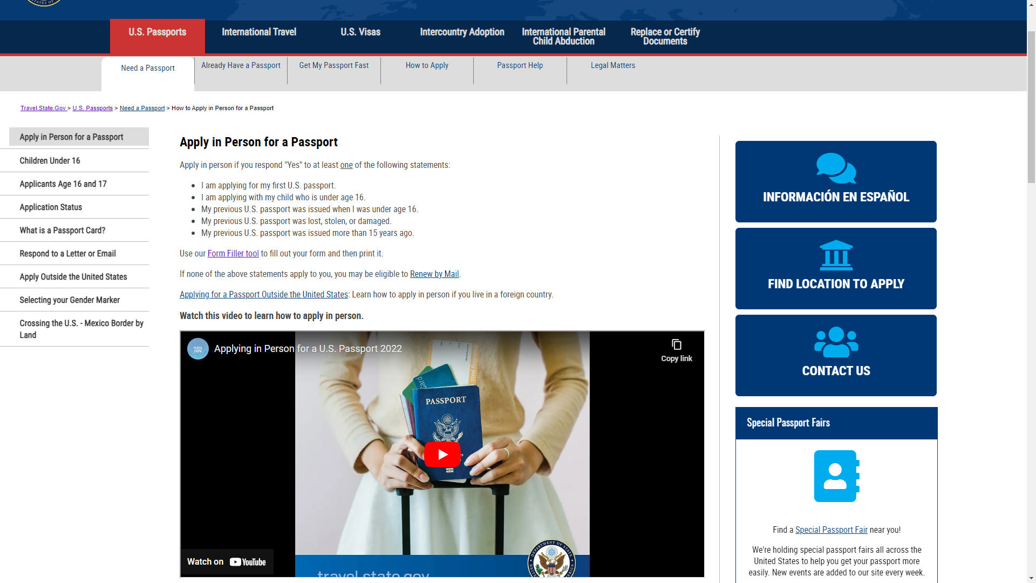

Locate and carefully read the “Provide Evidence of US Citizenship” page.

Click and read carefully all other tabs in order. Locate the “submit your Completed Application” tab, click “Acceptance Facility” link. Bring completed application, payment, photo, and as many accepted ID’s as possible. More is better than the minimum.

You may Contact Associate Professor David Rath, rathd@roanestate.edu or cell 865-679-1859 for help or assistance with securing a passport.
Once you have completed the new passport book form, filed it at your local Passport Acceptance Facility, and paid the required fees complete the RSCC Passport Scholarship Application and Agreement form found on the RSCC International Education webpage. Send it to the email address listed along with a photocopy of your passport for reimbursement.

For questions concerning this program or reimbursement contact Associate Professor Casey Cobb at cobbcc@roanestate.edu

