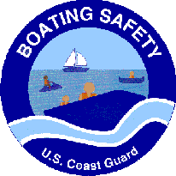
Boating Safety Tips
- Always wear a life jacket.
- Avoid alcohol.
- Be especially careful on personal watercrafts.
- Children younger than age 13 must wear a U.S. Coast Guard approved PFD while underway.
- Enroll in a boater education class.
- Don’t overload your boat.
- Operate at a safe speed.
- Always have a passenger serve as a lookout in addition to the operator.
- Watch out for low water areas or submerged objects.

Always Wear a Personal Flotation Device (PFD) or Life Jacket
- Most boating fatality victims were found (recovered) NOT wearing a PFD.
- Always carry extra PFD’s in both adult and child sizes.
- Children younger than 13 years old must wear a PFD while underway.

Avoid Alcohol
- The probability of being killed in a boating accident doubles when alcohol is involved.
- Operating a boat under the influence is just as dangerous as driving a car after you’ve been drinking.
- Boating while intoxicated (BWI) is strictly enforced and carries penalties similar to driving while intoxicated penalties, including possible Driver’s License suspension.

Enroll in a Boater Education Course
- It’s a good idea for the whole family to enroll in a boater education course.
- A majority (52%) vessels involved in boating accidents are operated by persons 26-50 years of age.

Be Especially Careful On Personal Watercraft (PWC)
- PWC operators and passengers must wear a U.S. Coast Guard approved PFD.
- Before you borrow or rent a PWC, take the time to learn how to operate the vessel and the rules of the waterway.
- Obey the 50-foot rule! Maintain a 50-foot distance from other PWC’s, vessels, persons, shore, or stationary platform or other object unless operating at headway (idle) speed.

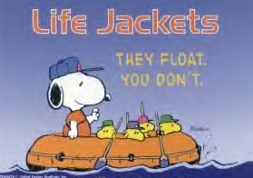
Operate at a Safe Speed
- Although there are no numerical speed limits on the water, citations may be issued for excessive speed or reckless operation. Use common sense, and operate at a safe speed at all times — especially in crowded areas.
- Excessive speed is a rate of speed greater than is reasonable or prudent without regard for conditions and hazards or greater than will permit a person to bring the boat to a stop within the assured clear distance ahead.

