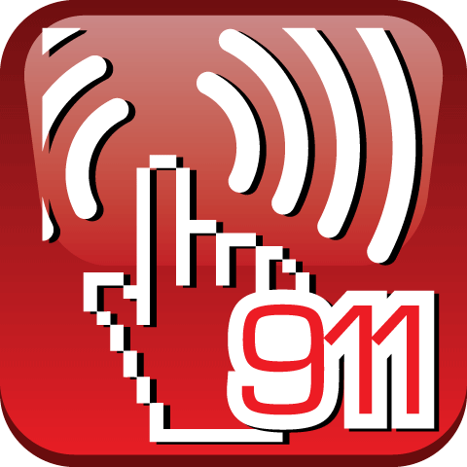
In many work places, first aid is administered by staff that are trained in how to provide basic medical assistance. For our campuses, that is the Campus Police. Often that involves some type of wound that is bleeding. We are going to offer an easy acronym, B-L-E-E-D, that can help you remember what to do when someone is bleeding. This applies to injuries around the home as well as at work. If the injured person needs further treatment, our local first responders will be contacted via 911, to assist with treatment, and to transport them if needed.
This information, as well as many other "how-to" tips for basic medical assistance can be found on a free app for smart phones from the American Red Cross, called "The American Red Cross First Aid App". If you haven't already downloaded it, here's a link: http://www.redcross.org/mobile-apps/first-aid-app. We recommend this app for everyone, at work or at home. And it's convenient to have handy when taking the kids on vacation!

When faced with any injury, make sure your scene is safe, meaning you won't get injured while trying to help them, and then remember B-L-E-E-D:

B Barrier:
Put a barrier between you and the wound. As explained in the app, this means gloves. But if gloves are not available, you can use a plastic sandwich bag as a barrier. (We got that tip from the Red Cross app.)

L Locate / Examine:
Check the injured person to see if there is a bone sticking out of or something (like glass, a nail, etc.) embedded in the wound site. And look to see whether the injured person is in shock. Reassure them if need be, and if possible, have them sit or lay down.

E External Direct Pressure:
Apply direct pressure to the wound. The pressure should be about the same as a firm handshake. If possible, you can have the patient hold the dressing and apply direct pressure to their own wound.

E Elevate:
Elevate the wound above the level of their heart if possible. This will slow down the flow of blood.

D Dressing:
Use a sterile dressing if possible. If one is not available, a clean cloth can be substituted. If blood soaks through the first dressing, do not remove it, but apply a second one over top.

