SAFETY TOPICS –Snakes and Poisonous plants
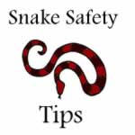
For people that work outdoors there is a good chance that you could run into a snake. Construction, farmers and landscapers should follow snake safety tips while working. There are different types of snakes all over the country. It is important to know what snakes are common in your area. You should also be aware of which snakes are poisonous and those that are harmless to humans. While snakes are around all year they tend to be the most active between the months of April through October when the weather is warmer. Every year there are nearly 7,000 snake bites but only one or two become fatal since there is anti-venom which stop the spread of poison in a body if it is used in time.

Preventing Snake Bites At Work
There are several snake safety tips that will help reduce the presence of snakes in your work area. By eliminating the ideal conditions for a snake you greatly reduce the chance of snake bites at work.
- Keep grass cut short. Snakes love to lay in high grass where they are often concealed from your view
- Wear long pants and boots. Tuck your pant legs into your boots. This will help prevent snake bites on your legs
- Wear protective gloves when grabbing things off of the ground
- While bushes, shrubs and flowers look beautiful you should keep them a few feet away from sidewalks or other walk ways. Small bushes and flower beds are a great place for snakes to hide
- Never leave food setting out. Small animals such as rats, birds and squirrels are attracted to food. Since snakes pray on small animals there is a good chance they will follow them to their feeding ground
- Don’t keep materials piled up outside. Wood and brick piles make great hiding places for snakes. Also piles of leaves or other debris from the work site can make a great home for a snake
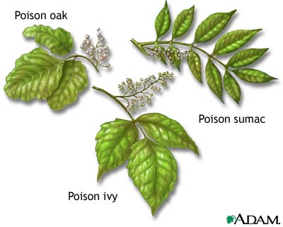
- If you see a snake while working back up slowly and call the local animal control center
Anyone working outdoors is at risk of exposure to poisonous plants, including poison ivy, poison oak and poison sumac.
According to NIOSH, when a person comes in contact with the sap oil of poisonous plants – either through direct or indirect contact, or inhalation of particles when burning plants – an allergic reaction can occur. Symptoms of exposure include rashes, swelling, itching, and bumps and blisters.
To help prevent exposure:
- Wear long sleeves, long pants, boots and gloves when working outdoors.
- Wash exposed clothing separately in hot water with detergent.
- Use skin lotions containing the ingredient bentoquatum.
- Do not burn plants that may contain poisonous plants. Inhaling smoke from these plants can cause severe allergic respiratory problems.
If exposed to a poisonous plant, NIOSH recommends these first aid tips:
- Rinse skin with rubbing alcohol, poison plant wash, or a degreasing soap or detergent as soon as possible.
- Clean under your nails.
- Apply wet compresses, calamine lotion or hydrocortisone cream to the skin to reduce itching and blistering.
- Call 911 or go to an emergency department if you have a severe allergic reaction (or if the rash is on the face or genitals), such as swelling or difficulty breathing, or have had a severe reaction in the past.

