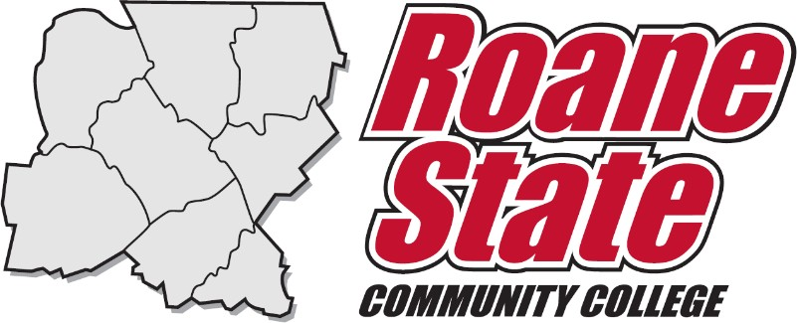

Roane State Community College/Passport Scholarship Application and Agreement

Last Name: First Name: Middle Initial: ____

Student ID: Date of Birth: __________

Street Address: City:

State: Zip Code: _ Citizenship: Phone:

Email Address: Academic Advisor:

(one that you use)

PASSPORT SCHOLARSHIP TERMS & CONDITIONS

This application/agreement serves as a binding contract between the applicant, hereafter referred to as “Student” and the Roane State Community College International Education Department, hereafter referred to as “Association”. By signing this agreement, the Student accepts the International Education U.S. Passport Application scholarship and agrees to adhere to the following requirements. The Student further understands that a violation of the following requirements may result in termination of any future International Education scholarships and may require reimbursement.

Student Terms
The Student is being awarded the aforementioned scholarship for the express purpose of acquiring a U.S. passport and potentially participating in an international educational course/ study abroad program offered or approved by the Association. To receive the scholarship, the Student promises to do the following:
- Complete the required forms for applying for a U.S. Passport and submit them to the appropriate officials.
- Provide a copy of the passport when received to the International Education Office.
- Potentially, participate in an International Education course/study abroad program, including travelling with the group – requires a GPA of 2.0 or better in all college-level coursework
- Receive a passing grade (if applicable) upon completion of the International Education course/study away cultural program
- Behave according to the Association’s Code of Conduct

Association Terms
The Association will award the Student with a $50.00 scholarship (paid directly to the Student) upon receipt of the new passport. If accepted into a RSCC study abroad program (or RSCC/TnCIS partnership program) an additional scholarship will be awarded to cover the full cost of the passport (paid into the international education course fund in the name of the Student).
Any Student who withdraws from a RSCC International Education program for any reason after the published payment deadline may be required to repay the scholarship. In addition, any Student who participates in a RSCC program and whose conduct/behavior necessitates disciplinary action and/or who fail to pass the course(s) for which they are enrolled during that program, may be required to repay the scholarship.
Scholarship repayment is a decision left to the sole discretion of the Association and Roane State Community College. If repayment is required, a hold will be placed on the Student’s account at Roane State until repayment of scholarship has been made. The Student will not receive grades, transcripts, or be allowed to register for future terms.

I have read, understand and agree to comply with the above.

Signature:

Printed Name:

Date

If under eighteen (18) years old, signature of parent or legal guardian required.

_________________________________________________ ___________________
Parent’s or Guardian’s Signature Date

Once you receive your passport, please contact Associate Professor Casey Cobb at cobbcc@roanestate.edu to receive your $50 scholarship

