FACILITY USAGE APPLICATION |  | Page 1 of 2
Applicants submit completed application to the designated campus contact listed in Attachment A.
________
INSTITUTION APPROVAL IS CONTINGENT ON THE APPLICANT’S SUCCESSFUL COMPLETION OF ALL FINANCIAL AND/OR INSURANCE OBLIGATIONS AS MAY BE REQUIRED BY THE INSTITUTION.
Please type or print:
Name of Organization/Individual: Contact Person: ______
Mailing Address:

State:
_ __
Zip:

Phone Number: ______
City: Email Address: ______
Is the billing address the same as above? If not, please indicate where invoices should be sent:
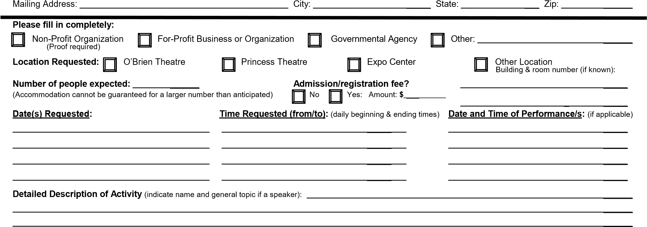
Name: ___ Phone: Email Address: ______
Note: Any affiliated entity or affiliated individual or non-affiliated entity or individual wishing to assemble, demonstrate, distribute literature or engage in similar public activity on one of the Roane State campuses must complete the request (application) at least five business days in advance of the desired date of the activity. The Vice President for Business and Finance or designee will review the requests that relate to or will take place on the Roane County Campus. The appropriate Site Director will review the request for the other Roane State higher education centers. Approval or denial of the request will be in writing and may take the form of an email message. Disapproval of the request to use the designated areas will include a statement regarding the basis for the disapproval. RSCC GA-06-01 governs such activities and designates areas on each campus where such activities may occur.
** Copies of marketing materials need to be provided to the designated campus contact prior to advertising the event! **
Please list any special needs below:
Food Service: Harriman Campus and Oak Ridge Branch Campus events must use College food service vendor.
Room Setup (Check all that apply): Tables: ____ How many? ______ / Chairs: ____ How many? ______ / Podium: _____ / Other: __________
Audio/Visual:_ Arrangements will be made through the Audio Visual Services. Contact information will be given when reservation is confirmed.
_____________________________________________________________________________________________________
Safety and Security (describe special needs): ____________________________________________________________________________________

OTHER:________________________________________________________________________________________________________________________

______________________
FOR INSTITUTION USE ONLY: Total Charges: $
APPROVED DENIED Charges : Deposit Due: $
Balance after Dep.: $
Date: Facility: Date Dep. Paid: $ Comments: Payments Made on Account:
Custodial:

Security:

Technician:

Equipment:

Date: Amount: $

By:: Utilities:
TBR 2012
RSCC Policy Number: GA-06-02

FACILITY USAGE APPLICATION |  | Page 2 of 2
APPLICANT CERTIFICATIONS AND AGREEMENT TO TERMS OF USE:
(Please read carefully and sign. Application will not be considered if this section is not completed.)
On behalf of the applicant, I acknowledge by signing below that the Institution has made a copy of GA-06-01 and GA-06-02 available for review. Applicant understands that submittal of this application shall constitute agreement by applicant to the following conditions, in addition to the conditions described in those policies:
- The intended use of the Institution property and facilities by applicant does not violate, and actual use will not violate, the provisions of the Tennessee Board of Regents Policy on Use of Campus Property and Facilities or any policies or regulations of the Institution, or any federal, state, or local law or regulation.
- Any use of college property and facilities pursuant to this application that is contrary to such policies, laws, or regulations or that is inconsistent with the activity as described in this application constitutes grounds for the institution to remove the activity from college property.
- Any liability of the applicant to institution and third parties for any claims, damages, losses, or costs arising out of or related to acts performed by the university under this agreement will be governed by the Tennessee Claims Commission Act, Tenn. Code Ann. §§ 9-8-301, et. seq.
I hereby acknowledge that I have read the Applicant Certifications and referenced policies, and agree to abide by these requirements.
______________________________ Name of Applicant
By: Date:

Please mail or fax the completed form to the designated campus contact as indicated in Attachment A.

Reservations for use of facilities are confirmed when the applicant receives official notification from Roane State Community College authorizing the request. Due to the high demand for rooms, we will not confirm, pencil-in, or otherwise reserve space for non-affiliated groups by phone or verbal agreement. If there is any question as to the approval of your application, or if confirmation has not yet been received, please contact the designated campus contact in Attachment A.
TBR 2012

Attachment A

FACILITY USAGE CAMPUS CONTACTS
Roane County Campus (Harriman excluding Princess Theatre and O’Brien Theatre) Jeremiah Johnson  Email: Johnsonjt1@roanestate.edu Phone: 865-882-4590  Fax: 865-882-4521  Address: 276 Patton Lane; Harriman, TN 37748 | Princess Theatre & O’Brien Theatre  (Harriman) Courtney Minton Email: mintoncl1@roanestate.edu Phone: 865-354-3000 ext. 4856  Fax: 865-285-3305  Address: 276 Patton Lane; Harriman, TN 37748
Anderson County Campus (Oak Ridge)  Sandy Vann  Email: vannsl@roanestate.edu  Phone: 865-481-2000 ext. 4802 or 2301  Fax: 865-481-2018  Address: 701 Briarcliff Avenue; Oak Ridge, TN 37830 | Knox County Campus – Center for Health Sciences (Knoxville)  Kirk Harris  Email: harrisk@roanestate.edu Phone: 865-539-6904  Fax: 865-539-6907  Address: 132 Hayfield Road; Knoxville, TN 37922
Campbell County Campus (LaFollette)  Sharon Wilson  Email: wilsonsw@roanestate.edu Phone: 423-562-7021  Fax: 423-562-7022  Address: 201 Independence Lane; LaFollette, TN 37766 | Loudon County Campus (Lenoir City)  Susan Williams  Email: williamssm@roanestate.edu Phone: 865-986-1525  Fax: 865-988-8878  Address: 100 West Broadway, Suite 131; Lenoir City, TN 37771
Cumberland County Campus (Crossville)  Dewayne McGhee  Email: mcgheefd@roanestate.edu  Phone: 931-456-9880  Fax: 931-456-1933  Address: 2567 Cook Road; Crossville, TN 38571 | Morgan County Campus (Wartburg)  Melody Kees  Email: keysm@roanestate.edu Phone: 423-346-8700  Fax: 423-346-2168  Address: 150 Longview Drive; Wartburg, TN 37887
Fentress County Campus (Jamestown)  Cheryl Tays  Email: taysca@roanestate.edu Phone: 931-752-8320  Fax: 931-752-8319  Address: 632 N. Main Street; Jamestown, TN 38556 | Scott County Campus (Huntsville)  Skip Jones  Email: jonesfd1@roanestate.edu Phone: 423-663-3878  Fax: 423-663-3877  Address: 410 W. H. Swain Boulevard; Huntsville, TN 37756

