FIRE DANGER WITH 9-VOLT BATTERIES
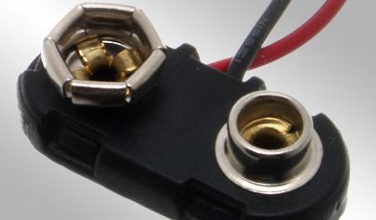
We’ve all heard that the batteries in smoke detectors should be changed at every time change—when we change to Daylight Savings Time in early March, and when we change back to Eastern Standard Time in early November. We switch out the batteries so our smoke detectors will keep working, they’ll detect smoke, sound the alarm, and allow us to escape before a fire spreads, right? And most of us probably also know that the batteries we remove should be recycled properly to avoid the possibility of contamination. But what you may not know about 9-volt batteries is that they can cause fires if they aren’t handled properly prior to disposal.
If you look at a 9-volt battery, you’ll see two posts on top, one of which has a positive charge, the other a negative charge. If either of those posts comes in contact with anything metal, like aluminum foil, steel wool, a paper clip, or even other batteries, the electrical reaction from the contact can cause the battery to heat up and start a fire. In fact, batteries carelessly tossed in “junk” drawers have been proven to be the cause of fires in kitchens and other areas in houses.
If you’re storing a battery for later use, keep it in the package in which it was purchased so it won’t come in contact with another battery or anything made of metal. If you’ve removed a battery for disposal and don’t have its original packaging, cut a short strip of electrical tape and put it over the positive and negative posts. You can do the same for a battery you’re storing if you don’t have its original packaging.
You need to remember to handle your own 9-volt batteries in a safe fashion. And now that you know about possible fire danger that can result when these batteries aren’t handled properly, you’ll want to pass this information on to your friends and loved ones. Smoke detectors are designed to save lives, but we need to remember the rest of the story on handling of those batteries!
We all should be committed to recycling spent batteries as a means to reduce waste in our landfills, stop harmful chemicals from contaminating our soil and water, and preserve our environment by decreasing the need for new raw materials from the Earth.
Battery Types that are recyclable:

Lead acid (Pb) Batteries
Nickel Cadmium (NiCd) Batteries
Nickel Metal Hydride (NiMH) Batteries
Lithium Ion (Li Ion) & Lithium Polymer (Li Poly)

Please click these links to news stories that show the hazards of batteries in “junk drawers” and the very real threat of a fire!
http://ehssafetynewsamerica.com/2012/11/05/updated-house-fires-caused-by-storage-of-9-volt-aa-batteries-on-the-rise/

https://www.youtube.com/watch?v=OSJH21WmALc

All spare batteries should have the terminals taped to prevent them from shorting out.

