4 - Standard 4 Measurement and Analysis of Student Learning and Performance
Edit (Check Out) Print
- Program Outcomes. List outcomes by accredited programs. Program outcomes should be used as part of a student learning assessment plan and be measurable.
AAS
AS
AS Accounting, etc.
- Performance Results. Complete Table 2 for Standard 4 Student Learning Results found under the Evidence File in the ACBSP documents folder above.
  - Provide a minimum of three examples of assessment data, reporting what you consider to be the most important data. It is not necessary to provide results for every process.
  - You must have at least one example of results for each accredited program.
Status: Not Started | Due Date: Not Set

QA Report

Assigned User
Not Assigned

Institution Response

For the AAS Business, regardless of the concentration students elect, and Financial Services enrolled students in these programs must take the following core courses as directed by the Tennessee Board of Regents (TBR):
Course Number | Course Name | Credit Hours
ENGL 1010 | ENGLISH COMPOSITION | 3
SPCH 1010 | FUNDAMENTALS OF SPEECH COMMUNICATION | 3
ECON 2010 | MACROECONOMICS
OR
ECON 2020 | MICROECONOMICS | 3
MATH | APPROVED GENERAL EDUCATION MATH COURSE | 3
HUMANITIES | APPROVED GENERAL EDUCATION HUMANITIES ELECTIVE | 3
BUSN 1305 | INTRODUCTION TO BUSINESS | 3
ACCT 1010 | PRINCIPLES OF ACCOUNTING I | 3
INFS 1010 | COMPUTER APPLICATIONS
OR
BUSN 1360 | SOFTWARE APPLICATIONS FOR BUSINESS | 3
BUSN 2370 | LEGAL ENVIRONMENT OF BUSINESS | 3
BUSN 2380 | PRINCIPLES OF MARKETING | 3

While there is not a one-to-one correlation between course numbers and titles for the common Business and Financial Services curriculum and Roane State’s Contemporary Management program, the material presented in that program contains academic content substantially similar to the courses listed above. The Contemporary Management Program was developed as an accelerated program, primarily designed to meet the needs of working adults. With that in mind, the program was designed to incorporate the academic content required to meet the curriculum standards of the business department, but the instructional scheduling and delivery was developed in an accelerated format to meet the needs of the adult working learner. This is important since Roane State requires an end-of-program exam for all graduates in the Business, Financial Services, and Contemporary Management programs. It is important to provide the aligned curricula to ensure that all students in programs under the Business Department “umbrella” leave with the faculty’s knowledge that they have received an equivalent core education regardless of the delivery format.
This is also important since the department made a change in the end-of-program exam. We require an end-of-program capstone course, BUSN 2399: Management Seminar for all graduates, embedding the end-of-program exam within that course, and assigning a grade percentage of 10% to the exam.
With the change to an imbedded graded exit exam covering the core areas of study (Introduction to Business, Accounting, Management and Supervision and Marketing we have the ability to evaluate the progress of all students in the diverse programs to determine what changes, if any, are necessary to the course presentation by program.
Since the exit exam is generally taken in the students last semester, the additional advantage we hope to enjoy is to work with the testing center to provide additional data information collection during the exam that will capture contact information with our students to enable Roane State Community College Business department to maintain contact with our graduates through surveys that can lead gathering of specific program graduates to seek input on changes that would have better served their needs.
This data gathering tool is in the process of implementation with the 22-23 school year.
Student success information is gathered at the individual course level for Principles of Accounting, Principles of Marketing, Introduction to Business, and Supervisory Management. Currently a post test is given for all but the Marketing course where final project is utilized to access student success data for each course. As indicated above, we also conduct an end of program assessment to determine student success by program.

The results of the individual course assessments are presented below:
Accounting
Students will be able to:
- Demonstrate knowledge of generally accepted accounting principles.
- Complete the steps in the accounting cycle and prepare the financial statements.
- Determine the application, interpretation, and financial statement effect of specific accounting methods and procedures.
The Business program recently began to analyze the results of its Accounting exam by the course learning outcomes and by programs offered by the department and by students from other programs. The Principles of Accounting class is required by both AAS Business majors and all AS transfer students declaring a major in Business at Roane State. The course learning outcomes for this course listed above are aligned with the Tennessee Board of Regents (TBR) common curriculum course inventory. The course learning objectives adopted by the TBR common curriculum committee are presented above. This exam helps provide the program with multiple measures of its learning outcomes.
Our goal is to achieve a 75% success rate for each of the Learning Objectives. Over the past two years, students have scored over 75% on two of the learning outcomes and 65% on the third outcome. Performance on the exam, was consistent across academic year 2021 and 2022. Students consistently scored the lowest LO 3, which assess students’ ability to correctly identify certain financial statement terms and to correctly use given data to correctly identify the impact on financial statements. See figures 1, 2, and 3.
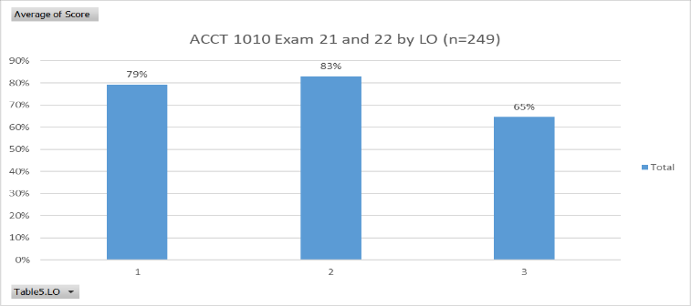
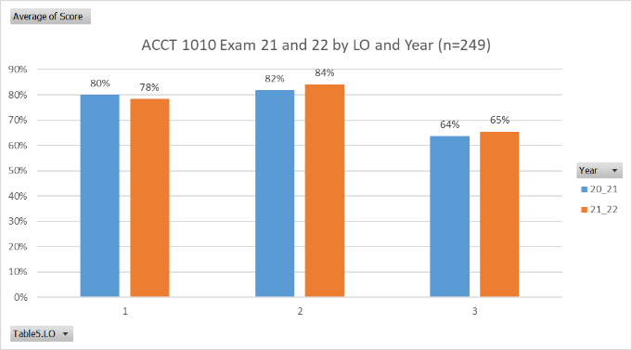
Figure 1 Figure 2

With the exception of CMGT, the scores were similar across programs. The lower scores from CMGT students is hard to draw conclusions from because of the low number of CMGT students completing this assessment. In general, Accounting and Transfer students performed the best on the exam. However, differences in outcomes by LO were typically within a 5% range.

Breaking the results down by program and learning objective, it becomes clear that students regardless of program need improve their ability to demonstrate learning outcome 3. See Figure 3.
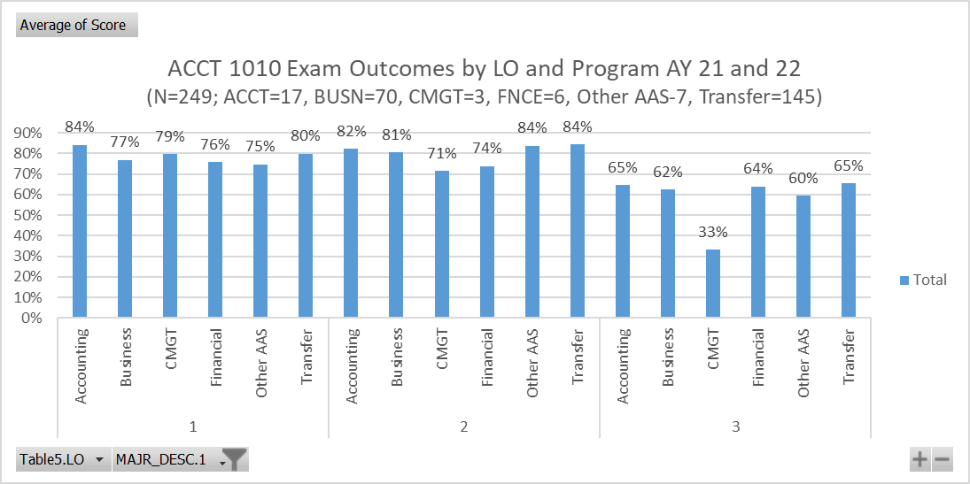
Figure 3
Use of Results
Based on the ACCT 1010 exam results, it is clear that students need more instruction in financial statement analysis and the impacts of individual transactions on the financial statements. Instructors will spend more time on the process of tracing transactions from the initial entry to the presentation on the end of period financial statements.
Principles of Marketing
Students will be able to:
- Explain the concept of marketing and how marketing strategies are planned, implemented and controlled.
- Explain the process of market segmentation and target marketing.
- Identify the elements of the marketing mix and how they are used to satisfy marketing opportunities.
The Business program recently began to analyze the results of the student success in the Principles of Marketing course by the course learning outcomes and by programs offered by the Business Department. The course learning outcomes for this course listed above are aligned with the Tennessee Board of Regents (TBR) common curriculum course inventory. The Business program has implemented a final project in the BUSN 2380 Marketing course as a means to assess student's proficiency in three learning outcomes that are aligned with the program's Marketing learning outcomes. The project is assessed with a rubric that evaluates students on each of the course learning outcomes. This was a pilot year for the assessment. Students generally performed well on learning outcomes 2 and 3 with greater than 80% scoring in the mastery level. Students appeared to struggle more with learning outcome 1 with only 62% (13/21) demonstrating proficiency or mastery. This learning outcome focused on student’s ability to plan and implementation of a marketing strategy. The students were able to identify the elements of the marketing plan but did not demonstrate the same level of understanding of developing the plan. Students' difficulty with this learning outcome may indicate that the individual elements of the plan can be memorized but the abstract idea of developing and documentation of the plan needs additional instruction. The results of the learning outcomes matrix presented below:
Figure 1

Student demonstrates… | LO1 | LO2 | LO3
Mastery | 52.4% | 81.0% | 85.7%
Proficiency | 9.5% | 0.0% | 0.0%
Near proficiency | 0.0% | 0.0% | 0.0%
Not Proficient | 38.1% | 19.0% | 9.5%
Proficiency or Mastery | 62% | 81% | 86%
Additional information will be developed to assist students to see the planning process of the market plan implementation.
Introduction to Business
The Learning Objectives for Introduction to Business TBR Course Catalog Inventory listing is:
Students will be able to:
- Understand the various forms of business ownership, pros and cons of each as related to a given business, and the processes for formation.
- Understand the various functional areas of business operations and the interrelationship of these functional areas within the organization.
- Demonstrate student preparedness for further study in a variety of available fields of study within the business environment as well as provide additional information to assist students in determining a specific field of interest.
The Business program recently began to analyze the results of its BUSN 1305 exam, Introduction to Business, by the course learning outcomes and by programs offered by the department and by students from other programs. The course learning outcomes for this course listed above are aligned with the Tennessee Board of Regents (TBR) common curriculum course inventory. The course learning objectives adopted by the TBR common curriculum committee are presented above. This exam helps provide the program with an early measure of student outcomes and multiple measures of its program learning outcomes.
Over the past two years on average, students have scored over 75% on two of the learning outcomes and 73% on the third outcome. Students performed better in 2021/22 compared to 2020/21. This was especially apparent on LO 3 where in 2021/22 students scored 81%, an improvement of 12% over the previous year. There was no evidence as to what to attribute this change in performance. Regardless, LOs 2 and 3 appear to be areas where students need more support. This LO 2 addresses questions that relate to specific activities in a business such as factors in production or individual factors in the product life cycle. LO 3 addresses questions related to the business environment itself such as the risk factors involved in business activities in general of specifically issues related to debt. See figures 1 and 2.
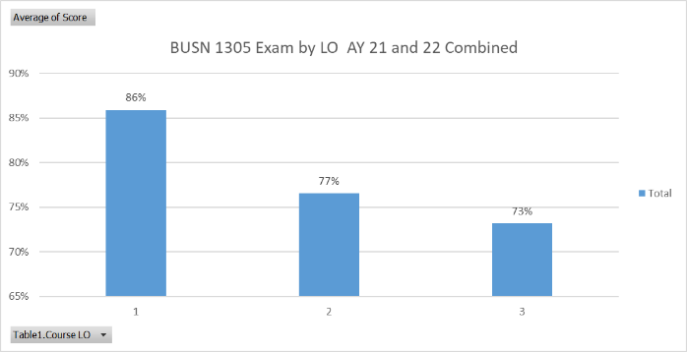
Figure 1 Figure 2
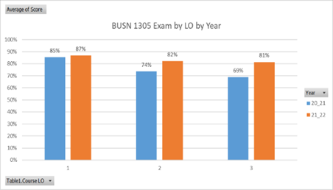
With the exception of FNCE students, the scores were similar across programs. The higher scores from FNCE students is hard to draw conclusions from because of the low number of FNCE students completing this assessment. In general, all Business program students improved their scores in 2021-22 school year over previous years. See Figure 3.
Figure 3. AY 2021 and 2022 BGE Exam by Program (n=182—ACCT=8, BUSN=63, CMGT=4, FNCE=2, Other AAS=11, Transfer=93)
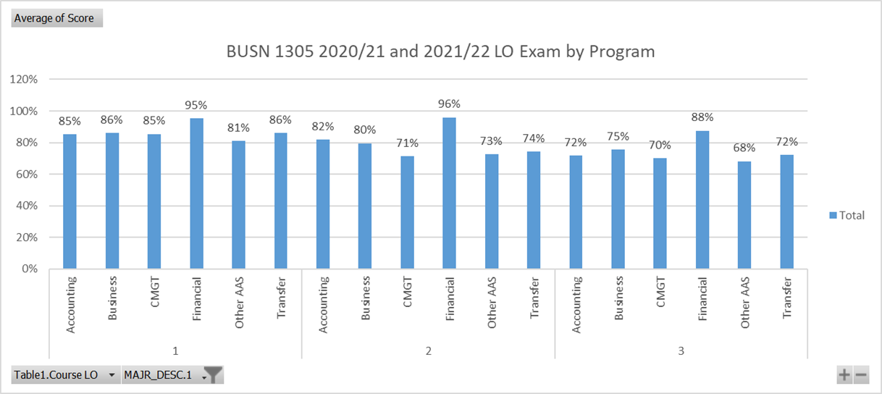

Supervisory Management
Students will be able to:
- Explain the principles and skills associated with effective planning, organizing, leading, and controlling.
- Describe techniques for coping with workplace dynamics, including appraisals, safety, conflict, and change in labor relations.
The Business program recently began to analyze the results of its Supervisory Management Course exam by the course learning outcomes and by programs offered by the department and by students from other programs. The course learning outcomes are aligned with one of the core programs learning outcomes. This exam helps provide the program with multiple measures of its learning outcomes.
Over the past two years, students have scored over 80% on two of the learning. Performance on the exam, was markedly better in 2021 than in 2022. Students consistently scored the lowest LO 2, which assess students’ ability to describe workplace dynamics and the relationship between supervisors and employees. See figures 1 and 2.
Figure 1 Figure 2
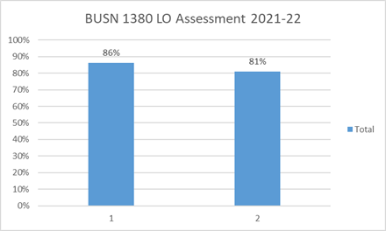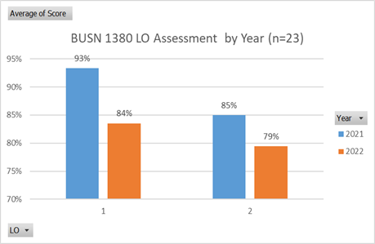
Because of the relatively small sample size, it is difficult draw conclusions about the differences between programs. However, comparing the general Business concentration to the overall scores of all exam takes, it is clear that general Business students did not do as well as other students (LO 1 82% vs. 86% overall; 74% vs. 81% overall).
Breaking the results down by program and learning objective, it becomes clear that students regardless of program need improve their ability to demonstrate learning outcome 2. See Figure 3.
Figure 3
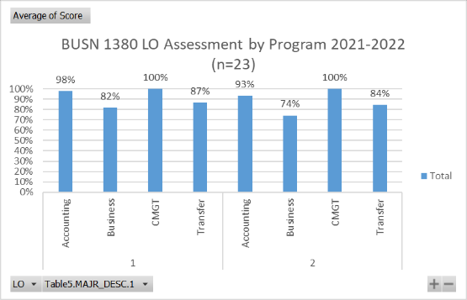
As indicated above, we also conduct an end of program assessment to determine student success by program.

End of Program - Business Graduate Exit Exam (BGE)

Learning Objectives for All Business Programs and Concentrations (Business, Contemporary Management, Financial Services)
The Business programs share four student learning objectives. These learning objectives are aligned with the learning objectives in the four core courses in the program (provided below). These four learning objectives are assessed by a summative Business Graduate Exam (BGE) given to all students at the end of the capstone BUSN 2399 course.
Students will be able to:
- Demonstrate knowledge of accounting principles and how to apply and interpret the financial impact of various accounting methods and procedures. (Aligns with accounting course learning objectives listed above.)

- Explain how the elements of the marketing mix and marketing segmentation concepts to develop are used in the development strategic marketing plan. (Aligns with Marketing course learning objectives listed above.)

- Describe the types of business ownership, fields of study available, career pathways, and the interrelationship of these concepts within the business organization. (Aligns with Introduction to Business learning objectives listed above.)

- Explain how to work through the challenges of the workplace dynamics to be faced at all levels of management. (Aligns with Supervisory Management learning objectives listed above.)

The Business program recently began to analyze the results of its Business Graduate Exam (BGE) by both program and the broad disciplines covered by the Business major’s four core courses in Accounting, General Business, Marketing, and Supervisory Management. Over the past two years, students have scored above an average of 80% on all areas on the BGE exam. Broken down by individual year, students appeared to do slightly better in 2021 compared to 2022. In 2022, students saw a small decline in their Marketing and Management related outcomes. The Management and Accounting sections of the exam have been the lowest scoring areas the BGE. See Figure 1 and 2.

Figure 1. BGE Exam by Program

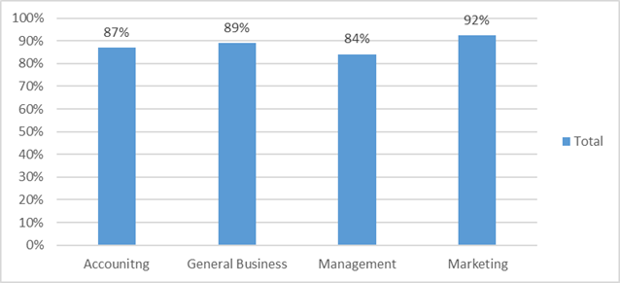
Figure 2. BGE Exam by Learning Objective by year (n=96—ACCT=10, CMGT=21, FNCE=2)
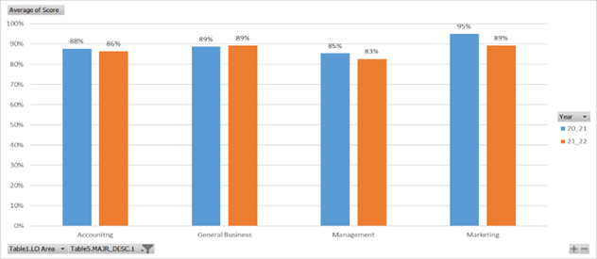
Within each of the programs, students have scored an 83% or better over the past two years. While students in all programs did generally well on the BGE, Contemporary Management program (CMGT) scored an overall 82% on the BGE in 2022 compared to other programs. This was 5% below Business Administration students, which represent the bulk of the majors. Both Financial Service and Accounting concentrators scored above 90% on the BGE. See Figure 3.

Figure 3. AY 2021 and 2022 BGE Exam by Program (n=96—ACCT=10, CMGT=21, FNCE=2)
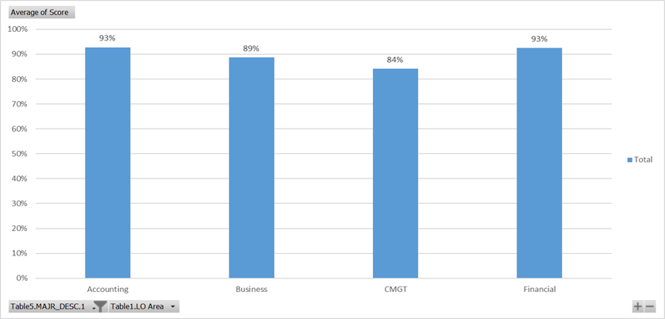

Breaking the results down by program and learning objective, it becomes clear that the Management section was the weakest area across programs and that CMGT students slightly lagged behind their peers. The volatility of the scores in the Financial Services students’ scores can be attributed the low number of graduates from this program. See Figure 4.

Figure 4. 2022 BGE Exam by Program, Learning Objective, and Year (n=96—ACCT=10, CMGT=21, FNCE=2)
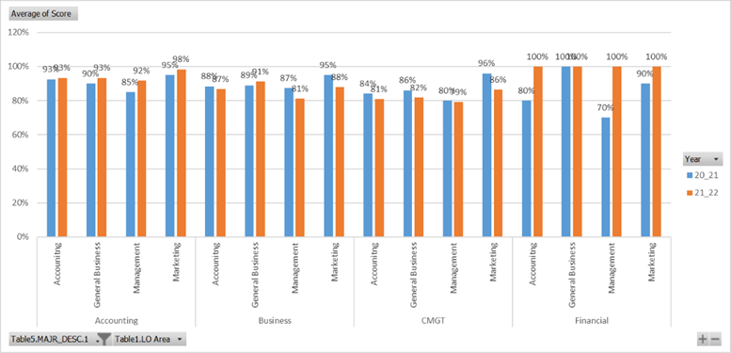

Sources
There are no sources.

