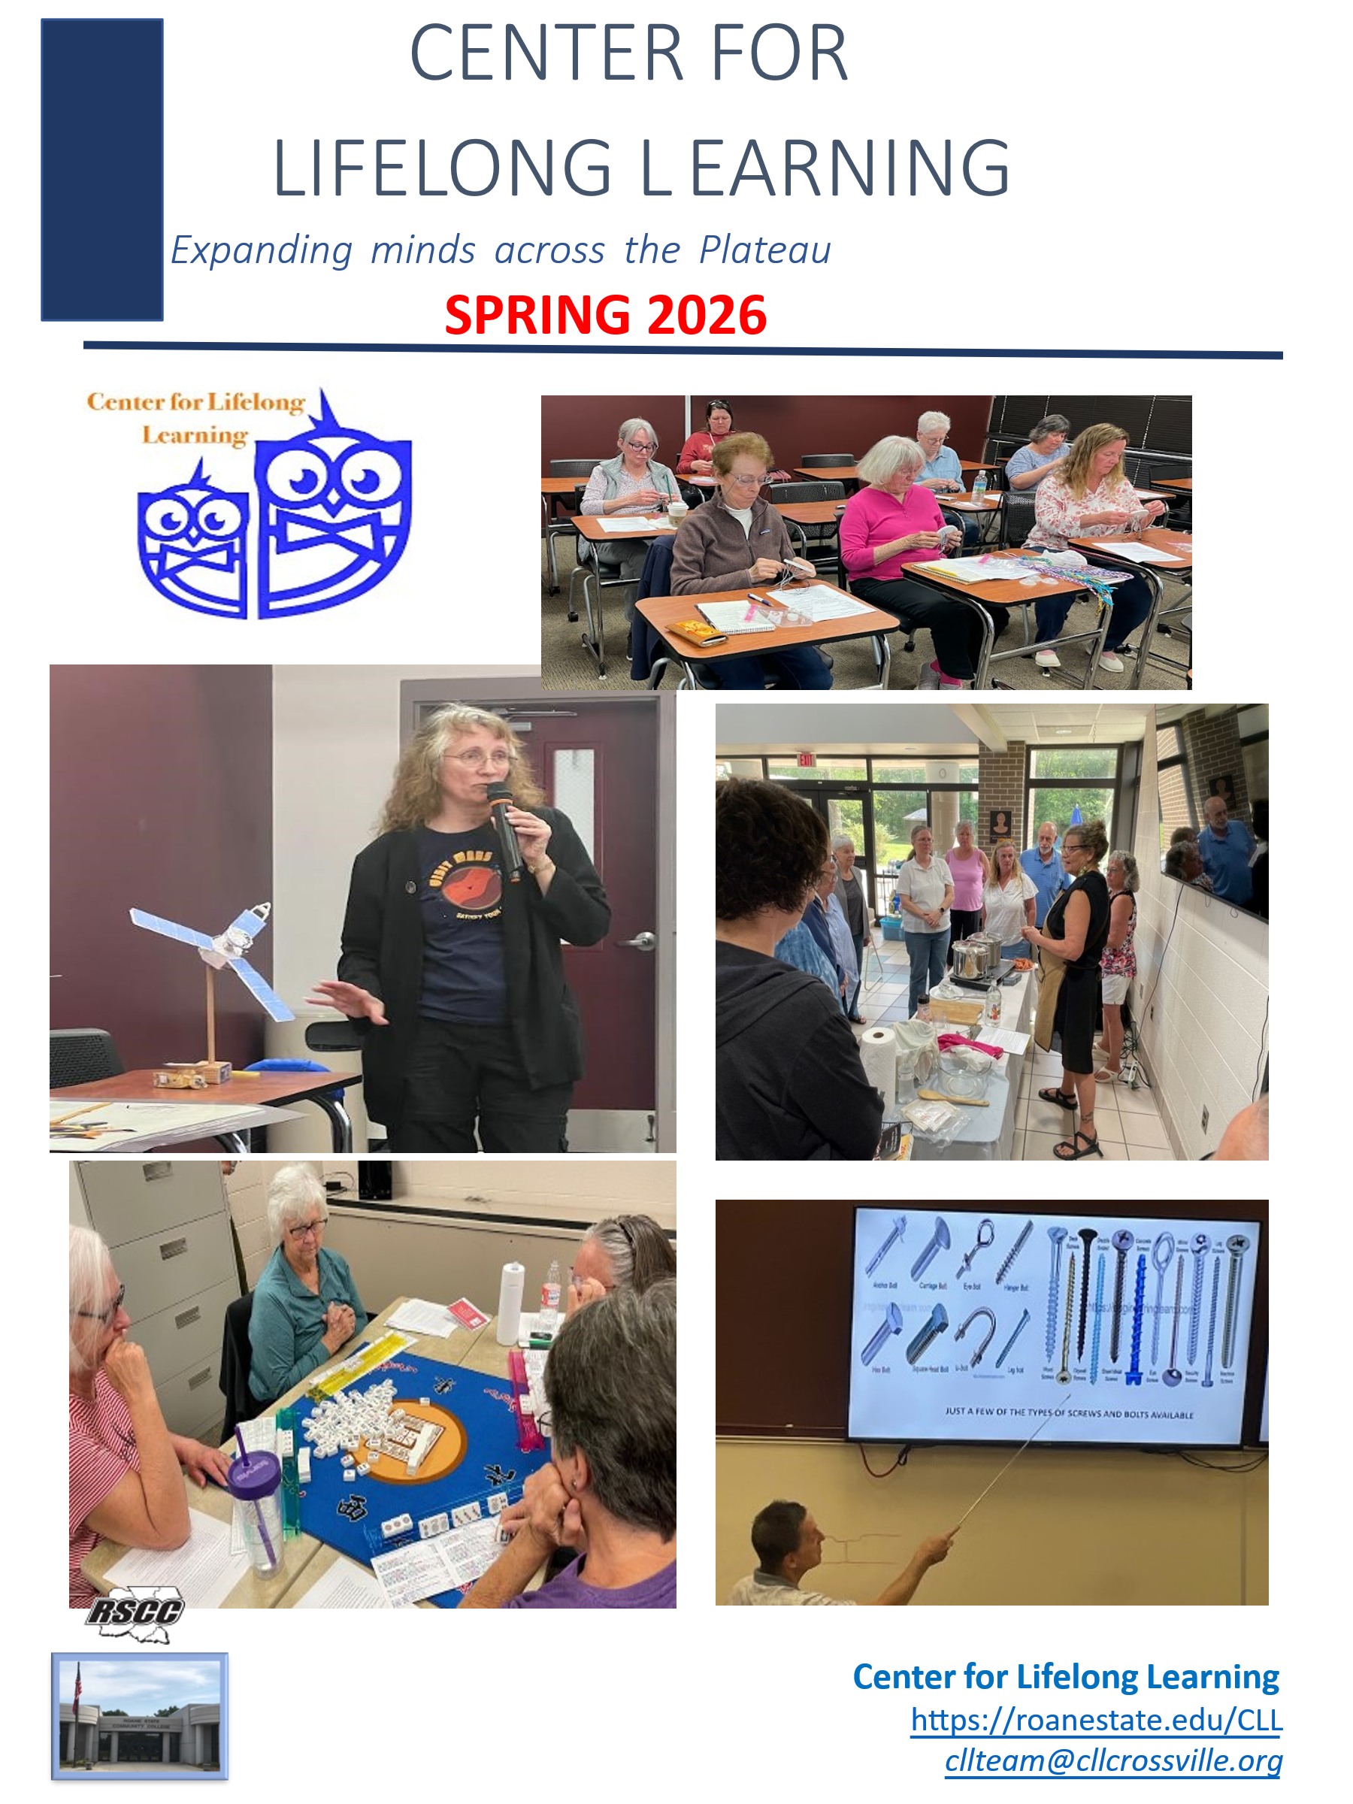
SUMMER 2026
The Center for Lifelong Learning (CLL) invites residents of Cumberland County and nearby communities to become members and take part in the joy of lifelong learning. CLL was started in 2016 by Holly Hanson, then campus director for Roan State Community College (RSCC), and her assistant, Bonnie Moedano. John Conrad and Judy Wade were instrumental in expanding CLL's offerings. CLL continues to provide our members with a supportive, community-based environment that enriches the lives of adults, regardless of age, background, or educational level. The Center for Lifelong Learning (CLL) is a 501 (c) (3) nonprofit organization.
CLL offers programs that reflect the community's interests and may include classroom sessions, fieldwork, local trips, or other activities. All presenters are volunteers who are passionate about their subject matter and wish to share their knowledge and experience with others. CLL is supported by RSCC, which provides classrooms and administrative support to the program.
We are actively seeking suggestions for future classes as well as volunteer presenters!

IMPORTANT NOTES
–CLL holds three semesters per calendar year, each typically lasting 3 to 4 weeks.
–Terms begin in the following months: Spring–March / Summer–June / Fall–October
–The 2026 Summer semester runs from June 1 to June 30.
–ALL students will need to create an account and pay membership fees before registering for classes. However, if a student registers for all three semesters for 2026, the account created can be used to register for classes in the 2026 Summer and Fall semesters.
–Register for classes via the CLL automated online registration system (Instructions are provided on the next page).
–Anyone can browse the class descriptions, BUT only users with an active account and who have paid the required membership fee may register for classes.
—Classes are filled on a first-come, first-served basis.
—Registration remains open, as space allows, after the semester has begun.
––Class dates and times are listed in the catalog
Current fees: $40 for all three semesters within the calendar year, or $20 per semester.
*For questions or concerns, please email us at cllteam@cllcrossville.org.
You should receive a reply within 24-48 hours.
MEMBERSHIP and REGISTRATION
Returning Students:
- Go to https://roanestate.edu/CLL (type this directly in the browser, not Google)
- Click on Membership, Registration, Class Listings
- Log on
- Proceed with registering for classes

Returning Students who only paid for the spring semester:
- Go to https://roanestate.edu/CLL (type this directly in the browser, not Google)
- Click on Membership, Registration, Class Listings
- Log into your account & Click Membership on the top Left.
- Click the blue "Select" button next to 2026 Full Year ($40) or Single Semester ($20)
- Fill in your payment information, agree to the Terms, and click "Submit".
- Continue to Login
- Proceed with registering for classes

New Students

- Go to https://roanestate.edu/CLL (type this directly in the browser, not Google)
- Click on Membership, Registration, Class Listings
- Set up your account under New User – top right of page Select “Individual” in first field “Type?”
- MAKE NOTE OF Your User Name and Password - CLL DOES NOT HAVE ACCESS TO THIS INFORMATION
- After submitting the form, you should see a welcome message that your account has been created.
- Select “Membership” at top of screen.
- Click on the blue SELECT button next to 2026 FULL YEAR($40) or SINGLE SEMESTER ($20)
- Fill in your payment information, agree to the Terms, and click "Submit".
- Continue to Login
- Proceed with registering for classes

Class Registration (Only those who have paid the annual membership fee or a single term)
- Go to https://roanestate.edu/CLL (type this directly in browser, not Google)
- Select “Membership, Registration and Class Listing”
- Log in to your account
- Select the semester and the category (or “Any” to see all classes)
- Click on the class title to see the class description.
- Click on the Register button to register for any class.
- PLEASE NOTE: Your registration will not be complete until you check out by clicking on the check-out cart (just like you do with Amazon). 
- You will receive a confirmation letter approximately
one week before the class.
"Commit yourself to lifelong learning. The most valuable asset you'll ever have is your mind and what you put into it."
-Albert Einstein

Online registration for FALL 2026 opens on SEPTEMBER 23, 2026.
Registration continues throughout the term unless a class is closed.

All class information is accurate at the time of publication.
Information WILL be kept current in the online listing at https://roanstate.edu/CLL

Notices of changes or cancellations will be sent via email (check SPAM folder)
Thank you for your patience and understanding.
IMPORTANT INFORMATION FOR SUMMER 2026
Unless otherwise noted in this catalog, classes will be held at:
Roane State Community College (RSCC) 2567 Cook Road, Crossville, TN 38571 Or the Cumberland Business Incubator (CBI) (across the East parking lot)
Ample parking is available in the large student lot on the EAST side of the main building.
Handicap parking ONLY is allowed in the faculty parking lot on the WEST side of the RSCC building.

TO DROP A CLASS
If you find you will be unable to attend an upcoming class for which you have registered, please sign into your CLL account and follow these instructions:
Go to roanestate.edu/CLL
Click on REGISTRATION AND CLASS LISTING
Click the LOGIN button at the top of the screen.
Enter your USERNAME and PASSWORD
Click on your NAME at the top right of the screen (next to the GEAR symbol)
Click MY ACCOUNT
Scroll to the bottom of the page and click the REGISTRATION tab
Locate the class you wish to drop and click DROP at the right side of the listing
Confirm by clicking OK in the pop-up window
or email cllteam@cllcrossville.org or call (931) 783-1541

CONTENTS

Art & Culture
*Introduction to Calligraphy………………………………………………………………...…...7
Computer
*iPad Basics……………………………………………………………………………….……………….7
*What’s the AI Revolution and What Does It Mean for You?…….…..……………8
Finance
*Avoiding the Impending Tax Trap………………………………………………………………8
Life Experiences
*Avalon Center:
Working to End Power-Based Violence Against Men, Women, and Children.......9
History
*Nixon: Triumph, Turmoil, Tapes, and the Truth…………..….….……….…………10
Medicine and Health
*People are Made to Move…………………………..…….…………………..……..…….…11
*Foraging on the Cumberland Plateau…………………………………..………....……..11
*Alpha-Gal: The Allergy from Ticks……………………………….…………….….…...…..12
*Legal Cannabis in TN………………………………………..………………….….………..……12
Science and Technology
*When Droughts Turn Dangerous.............................................................…13
*Project Hail Mary Physicis…………………………………………...…….……..….....….…13
*Moon Shot…………………………………………………………….……….……………….….….14
*Petroleum Demystified
From Ground To Home: How the Petroleum System Actually Works….…..….14
Government
*Learn About Your Government: Elections………………….…………………….…..…15

Outdoor Adventures
*Sailing Over the Ocean Blue………………………………..……………………..………….15
*Disc Golf………………………………………………………………………………………………..16

ART & CULTURE

Introduction to Calligraphy
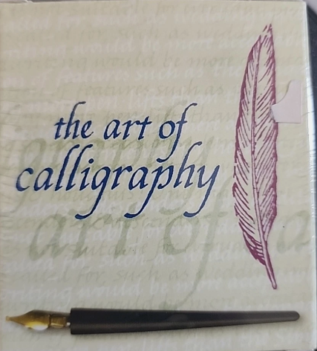
Cyndi will teach the basics of italic script. Starting with letter formation and then setting up pages. Participants will be provided a double-ended lettering pen and paper. You’ll be inspired by the variety of uses for this simple calligraphy style. There is a $5 fee.
Cyndi needed a hobby to fill her time while on disability, and she thought that teaching herself calligraphy would improve her handwriting. Instead, she learned the “Art” of lettering. After mastering several fonts, she began teaching calligraphy to patients in the mental hospital where she worked as an occupational therapist. She has created invitations, announcements, letterheads, and posters using her calligraphy skills.
Three Sessions: Tuesdays 6/2, 9, 16 9:00 – 10:30 Class Size: Min -5 Max -15

COMPUTER

iPad Basics

Did you get a new iPad recently, or have your children taken pity on you and passed down one of their iPads? Are you confused about iOS versus Windows? Would you like to learn how to organize files and photos? This class will walk you through the functions of your iPad and all things Apple. Much of the class will also apply to iPhones. Be sure and bring your pad and/or phone.
Tim Pickel was a Fine Arts Teacher for 33 years, including being an Apple Creative (Teacher). Following that, he worked for 7 years as a Water Purification Tech in Nicaragua, Belize, Guatemala, Zambia, Kenya, Haiti, and Uganda. He is now peacefully retired in Crossville, TN.

Three Sessions: 6/17,18,19 1:00 – 2:30 Class Size: Min-10 Max-20

What’s the AI Revolution and What Does It Mean for You?


Steve will provide an introduction to the AI technology revolution we are all experiencing. Today’s AI and how it works will be described. How AI can improve our lives will be reviewed. How can AI improve our lives? How are you already using AI? What are the potential risks of AI?
Data inputs are required for the functioning and growth of AI. Steve will explain policy options to manage them.

Steve Corley spent forty years building advanced machines that incorporated multiple processors, sensors, and actuators. A few examples: a walking robot, an automated lottery ticket inspection system, an automated roof truss inspection system, vision-based micron-accurate measurement machines, a robotic data storage library, automated microscope imaging systems, theater lighting control consoles, and a radar test set. His skill set includes real-time software, project management, parallel processing, image processing, and motion control.

One Session: Wednesday 6/10 10:00 – 11:30 Class size: Min -10 Max -30

FINANCE

Avoid the Impending Tax Trap

Stan will discuss the expiring tax credits for seniors and why Federal Taxes and fees will increase for everyone in the near future. He will also discuss a Senior Specific tax risk that few know about and many will be impacted by. He will offer strategies, such as Roth Conversions and other tactics, to minimize the impact and ensure you do not overpay unnecessarily.
After a temporary retirement of six years, Stan Stillwell’s 35+ years in the financial services industry qualify him to present possibilities that may be coming in the near future. It is his passion to help retirees live a meaningful, prosperous life without financial worries.
One Session: Tuesday 6/23 10:00 – 11:30 Class Size: Min -10 Max -30

LIFE EXPERIENCES

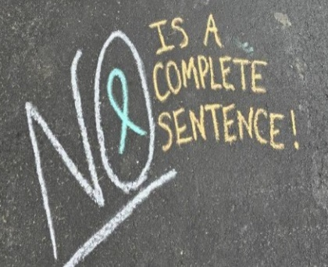
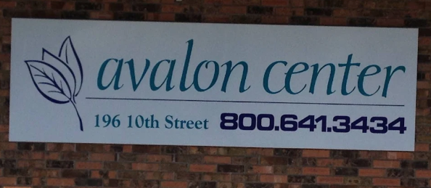
Avalon Center: Working to End Power-Based Violence Against Men, Women, and Children
Abigail will provide an in-depth overview of the Avalon Center, a nonprofit advocacy organization dedicated to supporting survivors of domestic violence and sexual assault. She will highlight the Center’s core services, including Emergency Shelter, Outreach Services, and the Child and Youth Program.
Abigail Cokkinias is the Outreach Coordinator for the Avalon Center, where she has worked since 2022. She began as a Domestic Violence Advocate serving Rhea, Bledsoe, and Van Buren counties, then transitioned to a Sexual Assault Advocate and later a Sexual Assault Long-Term Advocacy Case Manager. In her current role, she focuses on community outreach, education, and raising awareness to support survivors across the seven counties that the Center serves.
One Session: Wednesday 6/24 9:30 – 11:00 Class Size: Min -10 Max -30

If your class is in the RSCC main building, check the white board in the lobby for room assignment for the class.

HISTORY

Nixon: Triumphs, Turmoil, Tapes, and the Truth
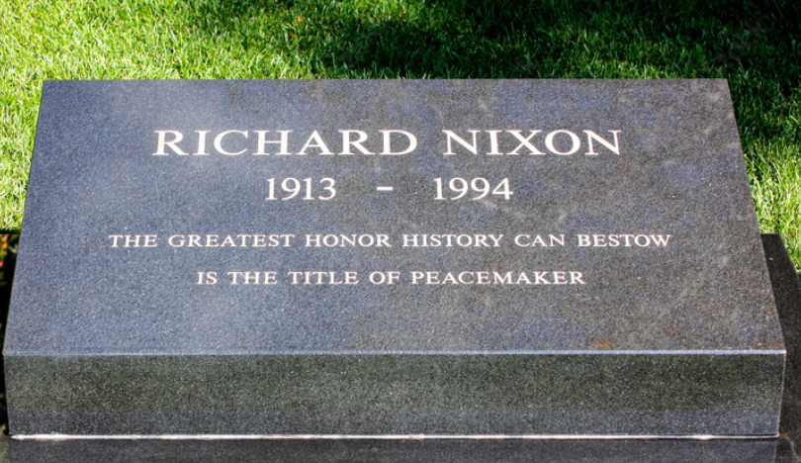
Alan will explore the legacy of Richard Nixon. From his early years into his political career, including his role in major Cold War developments such as opening diplomatic relations with China, and his domestic policies. He’ll also examine the Watergate scandal, the events that led to his resignation, and its lasting impact on American politics and public trust in government. You’ll gain a deeper understanding of Nixon’s complex leadership and the controversies that shaped his presidency.
Alan C. Lowe currently serves as the Executive Director and CEO of the Atomic Museum of Science and Energy and the K-25 Atomic Energy Campus in Oak Ridge, TN. He previously held positions as the archivist at the Ronald Reagan Presidential Library and Museum, Executive Director of Operations at the Office of Presidential Libraries in D.C., Acting Director of the FDR Presidential Library and Museum, and the Director of both the George W. Bush and Abraham Lincoln Presidential Libraries and Museums. Alan’s pet project is the creation of the Howard H. Baker Jr. Center for Public Policy at the University of Tennessee, where he was the inaugural Executive Director.
One session: Tuesday 6/30 10:30 – 12:00 Class Size: Min -10 Max -30

Visit the online catalog at https://roanestate.edu/CLL for the latest class information.
Check your email (including SPAM folder) before leaving home for any class

MEDICINE & HEALTH

People are Made to Move


This course is designed for adults seeking to understand the transformative power of exercise in managing health conditions, specifically multiple sclerosis (MS). Led by Jonathan E Bell, who has navigated his own MS journey since 2005, he’ll integrate his personal experience with practical strategies for reclaiming physical ability and improving the quality of your life through exercise.

With 25 years of expertise in proprietary government financial software, Jonathan has navigated a dynamic career that took an unexpected turn with his diagnosis of multiple sclerosis. Rather than succumb to despair, he established MSPositive—a platform aimed at fostering positivity and resilience among those affected by MS. Through this initiative, Jonathan is not only advocating for better resources but also inspiring others to embrace life’s challenges and discover what truly works for them.
One session: Thursday 6/18 10:00 – 11:30 Class Size: Min -10 Max -30

Foraging on the Cumberland Plateau

Discover local wild edible plants in this engaging indoor workshop. Mike will cover safe and sustainable foraging fundamentals with easily identifiable species, practical identification tips, and dangerous lookalikes. He’ll cover delicious food uses along with their traditional medicinal properties.
BYOB: Bring Your Own Books! Bring your favorite foraging guides to class for a show-and-tell. We’ll compare photos and descriptions to answer the rather important question: “Dinner or Darwin Award?” This class is educational only. You assume full responsibility for your own safety and any risks involved.
Mike Williamson is an avid lifelong learner with a wide range of interests. He enjoys seeking and sharing knowledge. One of his many interests is in native plants and their uses, especially for dinner.
Two Sessions: Thursday 6/4 & 6/11 1:00 – 2:30 Class Size: Min -10 Max -30

Alpha-Gal: The Allergy to Ticks

Tom will give an overview of alpha-gal syndrome, an emerging allergy linked to tick bites that can cause delayed reactions to red meat and other mammalian products. He’ll cover what alpha-gal is, how it develops, and how symptoms can appear hours after exposure, often making diagnosis challenging. You’ll learn the common signs and symptoms, risk factors, geographic patterns, and the role of ticks in triggering the condition. Tom has firsthand experience with dietary management and how to respond to allergic reactions. Much of Tom’s research has focused on tick behavior: how to avoid them and prevent them from biting. As the frequency of alpha-gal diagnoses increases, you’ve probably met someone or know someone dealing with it.

Tom’s journey with alpha-gal had led him to become an avid researcher of the condition. He’s had multiple flare-ups and so understands the ongoing difficulties of living with alpha-ga. Tom’s passion is disc golf, and he loves sharing it with others.

One Session: Monday, June 29 9:00 – 11:30 Class Size: Min- 10 Max-30

Legal Cannabis in TN
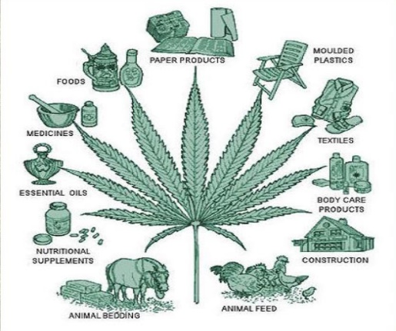
Maggie will cover the history of Cannabis. What is cannabis? What is THC? What is CBD? What are the best practices for growing Legal Cannabis. Can anyone grow it? What are the state and federal laws regulating? All these questions and more will be covered.
Maggie is a lifelong Tennessean. Working first in remodeling contracting and then in the maintenance/inventory department at Wyndham FFG, she traded those positions to follow her 26-year-long passion for “More-ganic” growing of herbs and veggies by opening her own company. For the past 5+ years, she has been growing, processing, and retailing legal cannabis in TN. as the CEO of Cann-I-Help Company Inc., 142 West Ave, Crossville, TN.
One Session: Monday 6/22 10:00 – 11:30 Class Size: Min -10 Max -30

SCIENCE & TECHNOLOGY

When Drought Turns Dangerous: The Hidden Risks Before and After the Dry

Mark joined a team of National Science Foundation (NSF) experts at Tennessee Tech to study drought in the southern Appalachians. His work doesn't just focus on droughts; it focuses on the transition into and out of drought conditions. During these transitions, disastrous flooding, severe storms, devastating fires, and other extreme elements reach their highest impact. Such events include the Gatlinburg fires of 2016 and Hurricane Helene in 2024.
Mark Baldwin (Meteorologist Mark) earned his bachelor’s degree in journalism from Tennessee Tech in 2003 and later a master’s degree in meteorology from Western Kentucky University. He worked for several weather forecasting entities before becoming a teacher at Mississippi State and then at Tennessee Tech. Mark is currently a research fellow on a National Science Foundation grant at TTU. He is also nearing completion of a PhD in environmental science.
One Session: Thursday 6/25 1:30 – 3:00 Class Size: Min- 10 Max-30

Project Hail Mary Physics

Unpack the real physics behind Andy Weir’s Project Hail Mary in this two-hour session. Explore photon rockets powered by Astrophage, relativistic travel, artificial gravity, and the story’s clever scientific twists. With live demos and simple calculations, discover why the novel feels so believable, and what it means for real interstellar travel. No advanced math needed. Perfect for sci-fi fans, space enthusiasts, and science lovers.
Mike Williamson served in the Navy (nuclear electrician, ship’s diver, and nuclear prototype instructor). An avid lifelong learner with a wide range of interests, he enjoys seeking and sharing knowledge.
One Session: Thursday 6/25 10:00 – 12:00 Class Size: Min -5 Max -30

Moon Shot
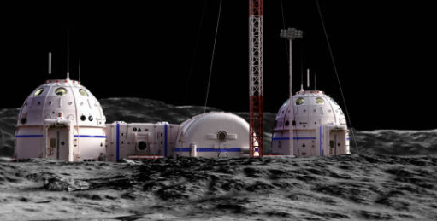
Living – and working – on the Moon. The Artemis II mission sent humans into lunar orbit for the first time in over half a century. What will it take to once again land humans on the Moon, and what are the plans for staying longer than just a few days? What are the reasons to do that? Theo will explore how the US landed on the Moon the first time, as well as what it will take to have a more sustainable human presence on our nearest neighbor in space, as both the US and China are working toward that goal.

Theo Wellington has a lifelong interest in the stars, earning a BS in Astronomy from Case Western Reserve University in 1981. She moved to Tennessee in 1986. Raising four kids, she helped coach high school Science Olympiad and worked 11 years at the Sudekum Planetarium in Nashville. Theo has been a member of the Barnard-Seyfert Astronomical Society since 2004, serving on the board and as president for four years. She became involved in the International Dark Sky Association in 2014 during Pickett State Park's successful application to be an IDA Dark Sky Park and has continued as an advocate for starry skies ever since. She enjoys public outreach and time with a telescope under the skies.
One Session: Tuesday 6/2 1:30 – 3:00 Class Size: Min -10 Max -30

Petroleum Demystified:
From Ground to Home: How the Petroleum System Actually Works


Energy prices and supply shape daily life and dominate the news. In this class, Brent will explain how petroleum moves from crude oil and gas extraction to the finished products we use. You'll gain a clearer understanding of the processes, terminology, logistics, tradeoffs, and limitations often referenced in the media.
Brent Freeman retired from ExxonMobil 3 years ago, after more than 30 years at the Joliet, IL, Refinery. One of his responsibilities was as a corporate resource on optimizing refinery energy consumption. He assisted roughly 20 facilities worldwide, improving their energy consumption competitiveness, giving him broad insight into diverse processing operations.
One Session: Monday 6/22 1:00 – 3:00 Class Size: Min -10 Max -30

GOVERNMENT


Learn About Your Government: Elections
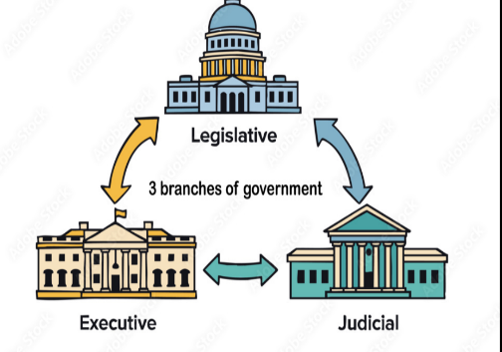
Elections are a fundamental part of democratic systems, allowing citizens to choose their leaders and influence government decisions. Cheryl will explain how elections work, including the process of voting, the role of candidates and political parties, and the importance of fair and transparent systems. Understanding elections helps us recognize our rights and responsibilities as citizens and highlights the value of staying informed and engaged in the democratic process.
Dr. Cheryl Brown, professor emeritus of Marshall University, has taught political science courses for years. Her favorite classes have always been centered around basic American government and history. Cheryl has developed a series for the Center for Lifelong Learning titled "Learn About Your Government.” Having a fundamental grasp of how our government works and its history benefits everyone.
One Session: Thursday June 11 10:30 – 12:00 Class Size: Min -10 Max -30
Outdoor Adventures

Sailing, Sailing Over the Ocean Blue
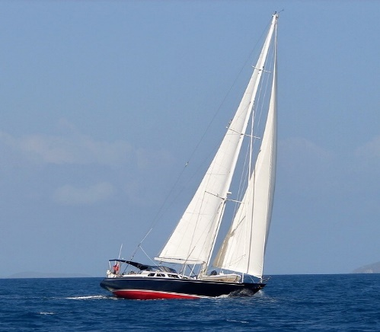
Sailing entails more than hopping on a boat. Mike will provide a practical introduction to chartering, covering everything you need to know before setting sail. He’ll share what a charter comprises and typical costs, along with guidance on choosing the best destinations and timing. He’ll also explain the qualifications and knowledge needed, the importance of crew compatibility, and how to handle provisioning and physical requirements. An ounce of preparedness is invaluable when sailing; things don’t always go as planned. Anchors away!
Mike brings over 55 years of sailing experience across a wide range of vessels and environments. He has captained monohulls from 12 to 51 feet and catamarans from 44 to 51 feet, navigating everything from inland lakes and coastal bays to open ocean waters. His extensive chartering background includes voyages throughout the Caribbean. Over the years, Mike has completed 17 charters with four different companies, reflecting both his deep expertise and enduring passion for sailing.
One Session: Monday 6/15 10:00 – 11:30 Class Size: Min-10 Max-30

Disc Golf

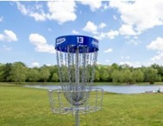
A short PowerPoint presentation will introduce the game, including its history, rules, safety, flow of the game, course options, disc options, throwing techniques, and local options for gameplay and participation. We will all play a 9-hole round of disc golf right on the campus of Roane State Community College. Playing 9 holes involves a leisurely walk of about 1 mile on mostly flat, mowed grass. Dress appropriately with comfortable shoes for walking on grass, and bring a hat. You are welcome to play all or any portion of the course as your fitness permits. Each grouping of players will be accompanied by an experienced player to provide advice and answer any questions. Discs will be provided. If you attended the class in the spring, you can still join us at 2:15 to play and get more pointers. No need to register, just show up.

Tom Gorman is a retired Nuclear Engineer, and Tom Pokorski is a retired Naval officer and civil servant. Both have played disc golf since its infancy in the 1970s, watched it grow from a fledgling sport played with Wham-O Frisbees aimed at trees and posts to a game played with specialized engineered discs, manicured courses, and worldwide professional competition.

One Session: Monday June 29 1:30 – 3:30 Class Size: Min–3 Max-13

USE OF PHOTOGRAPHS AND VIDEOS
CLL reserves the right to use photographs and/or videos taken in any CLL class or at any sponsored activity, without the expressed written consent of those included in the photograph/video. Photographs may be used in any CLL publication, including but not limited to: newsletters, brochures, course catalogs, emails, websites, Facebook pages, and/or other print or online media designed to help the organization meet its goals.

Board of Directors RSCC Crossville Campus
Russ Schubert -President DeWayne McGhee -Campus Director
Mike Durnwald -Treasure Allison Brendel -Support Staff
Holly Hanson Stan Tabor -Support Staff
Sue Kizer
Cumberland Business Incubator
Curriculum Committee Donna Ling -Support Staff
Sue Kizer -Chair
Holly Hanson
Management Team
Public Relations Mike Durnwald
Lisa West -Social Media Monique Freeman
Sue LeDoux -Print Media Sue Kizer
Theresa Winters -Public Outreach Angela Maycock
Russ Schubert
Catalog Editor
Richard J. Morawski

**IMPORTANT NOTIFICATION**

The course content provided in these classes is for informational purposes only. CLL and its committee members provide no warranty about the content or accuracy of the subject matter presented. Information provided is subjective. As a student, you are advised to verify all relevant presentations, statements, and information. If you need specific advice (e.g., medical, legal, or financial), please seek a professional licensed in that area outside the classroom.
CLL reserves the right to use photographs and/or videos taken in any CLL class or at any sponsored activity, without the expressed written consent of those included in the photograph/video. Photographs may be used in any CLL publication, including but not limited to: newsletters, brochures, course catalogs, emails, websites, Facebook pages, and/or other print or online media designed to help the organization meet its goals.

A tremendous thank you to all the volunteers behind the scenes who are making it possible to bring together eager students with talented presenters.

For questions or concerns, contact CLL at cllteam@cllcrossville.org

