CONTRACT TRANSMITTAL PROCESS
THE PRESIDENT IS THE ONLY PERSON THAT HAS THE AUTHORITY TO SIGN MOST CONTRACTS. (The VP of Business and Finance signs for the President.) Please see policy G-34-01 for the complete list of individuals who have signature authority for certain types of agreements.
A Contract Transmittal form must be completed for all contracts and agreements which will be entered through Dynamic Forms. This includes documents which have terms and conditions or make reference to terms and conditions that need to be signed for the college.
The “Contract Transmittal Form” which links to Dynamic Forms can be found on Purchasing’s webpage under Contract Information and Templates or by clicking here: https://qafederation.ngwebsolutions.com/idp/startSSO.ping?PartnerSpId=IdpRoaneStateLDAP&TargetResource=https%3a%2f%2fdynamicforms.ngwebsolutions.com%2fSubmit%2fStart%2f29498feb-7e2e-4fc5-b050-1f69bb58c963.
The Contract Transmittal Form will be signed by the Submitter then sent on to the VP for approval though Dynamic Forms. Please see Attachment A for the Dynamic Forms Contract process.
Timing
Timing for completing the process can vary widely depending on the type of contract and potential problems.
Specific actions on your part may speed up the process and make things smoother.
Make sure the facts, dates, etc. are accurate in your contract and be sure to complete any information that RSCC must provide.
Start the process as soon as possible. It takes time for reviews and approvals so plan to leave a reasonable amount of time for all of these steps to complete.
If the contract originates from the vendor, try to obtain the contract language in MS Word, if at all possible. Most contracts that originate from another party are written to protect their interests and will likely include language that we either cannot agree to or would not want to agree to. Sometimes it is easier to work out if we can take their agreement and markup our proposed additions and deletions using track changes in MS word.
The common most impermissible clauses are: indemnity, state of jurisdiction, warranty disclaimers, hold harmless clauses, attorney fees, and arbitration clauses. If you see headings or terminology such as this in your agreement, then it is probable that we will have to send an amendment for the vendor to review. The negation of the amendments can take some time so plan accordingly.
In many cases, it may be more effective to do business with a purchase order and avoid a contract with the vendor if the vendor is willing to accept our purchase order in lieu of their contract. Generally, a purchase order is not difficult to process and if we can avoid signing an agreement, protect our interests, and obtain the goods or services that you need, then this may be the best course of action.
Disclaimer: The information included in this document is intended to provide practical guidance for dealing with contract issues. Should anything in this document conflict with Federal laws, State of Tennessee Laws, TBR Polices and Guidelines, or other authoritative guidance then the applicable guidance will supersede this document.

ATTACHMENT A
SUBMITTING CONTRACTS THROUGH DYNAMIC FORMS
1 – Go to the Purchasing Webpage by clicking the link below and choose “Contract Transmittal Form” under Contract Information and Templates: https://www.roanestate.edu/?10825-Links-for-RSCC-Purchasers. This takes you to the login for Dynamic Forms to start the process.

2 – Choose the Executive Officer (your VP) on the dropdown menu
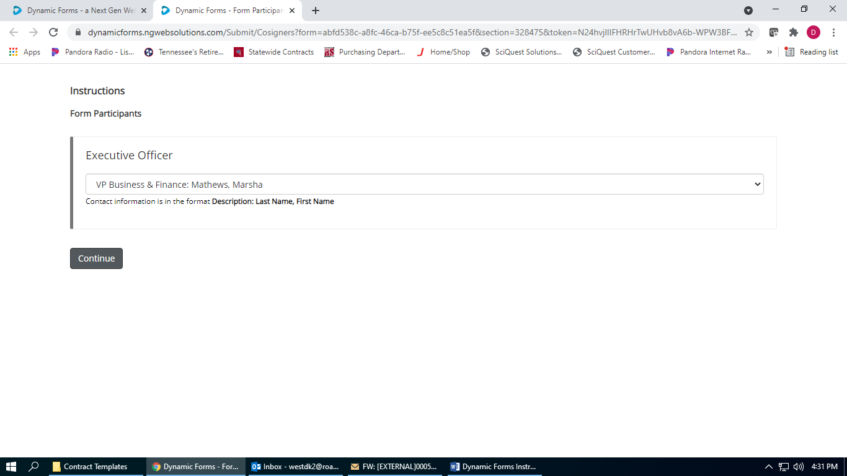

3 – You will not fill in the Contract number, this will be assigned by the Contract Officer
4 – Fill in all that cells that relate to your contract. The cells that have asterisks are required.
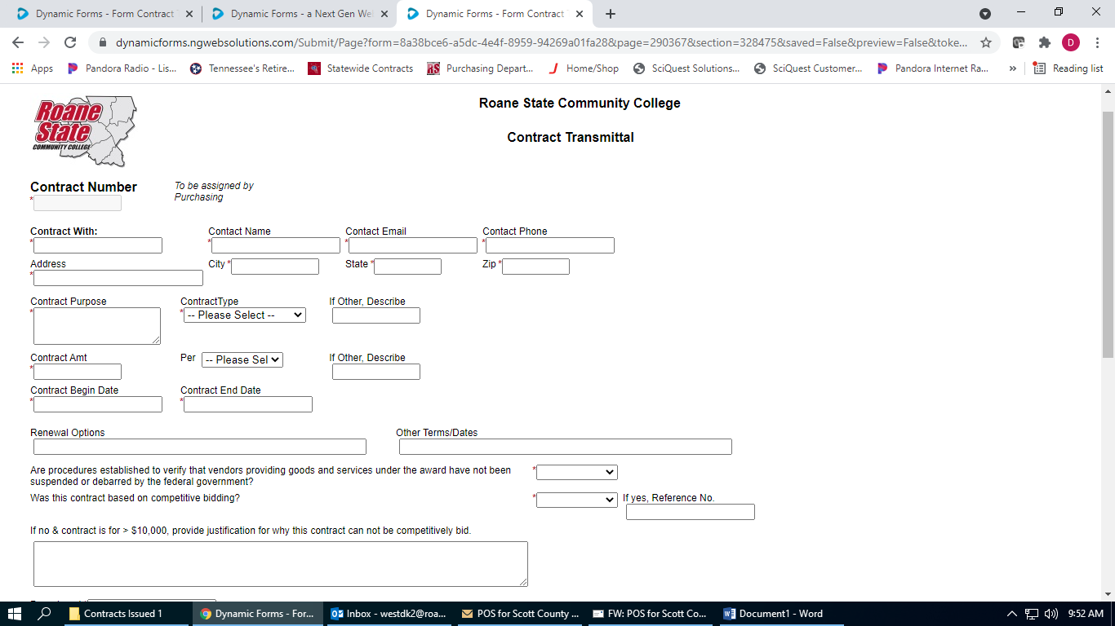

5 – Upload the contract in the box as seen below.
6 – Electronically sign and hit the submit form button.
7 –At this point, the form will be sent to your VP for signing.

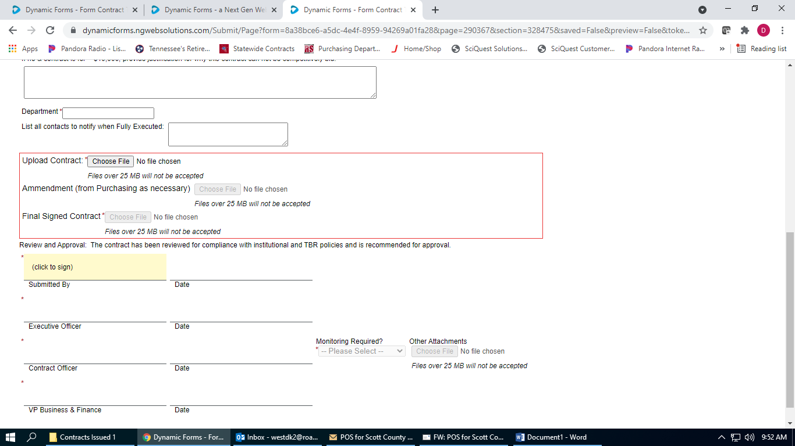

8 – The form will be sent to the Contract Officer (Dana West) to review the contract and draft any amendments that may be needed.
9 – Dana will send the amendment, if needed along with the contract to the vendor to be signed.
10 – After the contract and amendment are returned to Dana, she will upload the documents in Dynamic Forms. At this point, Dana will sign and submit the contract transmittal form.
11 - The form will then go to Marsha Mathews to review the contract and sign the contract transmittal.
10 – At this point, (Beth or Sherry) will receive the documents to sign for Dr. Whaley.

11 – When this is complete, the submitter will receive the final documents back by Dynamic Forms through an email. You click on the link in the email which will route you to Dynamic Forms to see the completed contract as shown below. You will choose Forms History to view the documents and save as a pdf for your records.

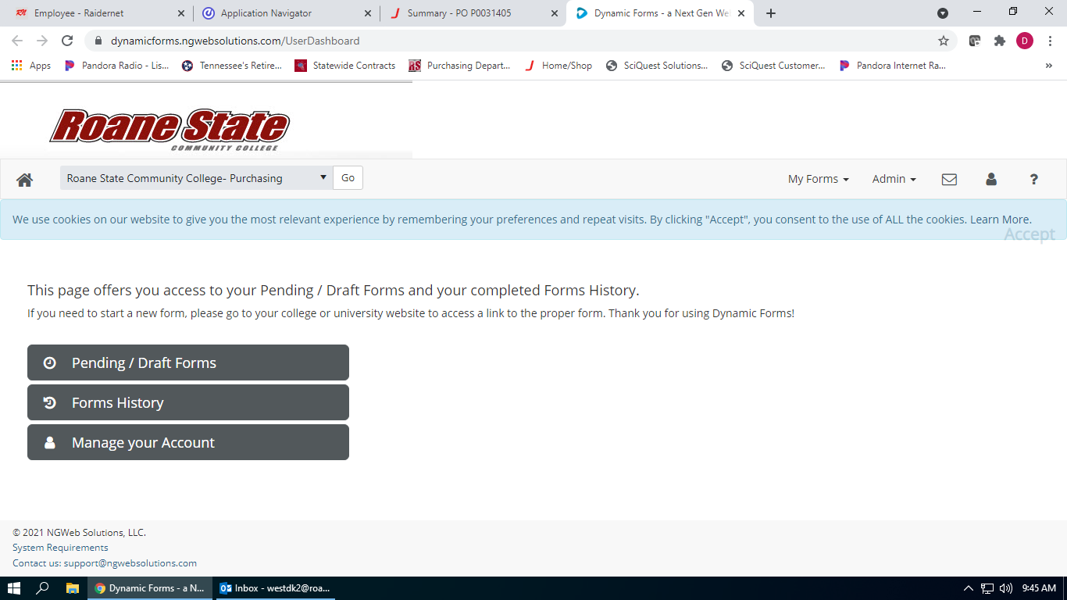

Please contact Dana West if you have any questions with this process at xt. 4657 or westdk2@roanestate.edu.

