CONTRACT TRANSMITTAL PROCESS
THE PRESIDENT IS THE ONLY PERSON THAT HAS THE AUTHORITY TO SIGN MOST AGREEMENTS/CONTRACTS/MOU’s/Quotes, etc. any document which needs a signature. (The VP of Business and Finance signs for the President.) Clinical Agreements are signed by the VP for Student Learning. Please see policy GA-34-01 for the complete list of individuals who have signature authority for certain types of agreements.
A Contract Transmittal form must be completed for all Agreements/Contracts/MOU’s/Quotes/etc. which will be entered through Dynamic Forms. This includes documents which have terms and conditions or refer to terms and conditions that need to be signed for the college. Please be aware that if you are purchasing software, there will more than likely be terms involved. Also, Quotes and Invoices may have a link to the Terms at the bottom of that document. Those terms should be downloaded and entered into Dynamic Forms for review. We will send back any requisition or credit card request if the Contract Transmittal form has not been completed. The final signed contract and transmittal form is required to be attached to the requisition or credit card request.
The “Contract Transmittal Form” which links to Dynamic Forms can be found on Purchasing’s webpage under Contract Information and Templates or by clicking here: https://dynamicforms.ngwebsolutions.com/Submit/Cosigners?form=2bda07bd-20d2-4182-9bfc-fa41a60001af&section=1018612&token=vGCJi5d2TKxvlkYwXTFe2qqIz7Ea-uk4WNq4dU3BjgQ
The Contract Transmittal Form will be signed by the Submitter to start the process. Please see Attachment A for the Dynamic Forms Contract process.
Timing
Timing for completing the process can vary depending on the type of contract and potential issues that may arise. Start the process as soon as possible. It takes time for reviews and approvals so plan to leave a reasonable amount of time for all the steps to be completed.
Make sure the facts, dates, etc. are accurate in your contract and be sure to complete any information that RSCC must provide such as a fillable form or blanks in a contract.
Most contracts that originate from the vendor are written to protect their interests and will likely include language that we cannot agree per TBR and the State of Tennessee contract policies.
The most common impermissible clauses are indemnity, state of jurisdiction, warranty disclaimers, hold harmless clauses, attorney fees, and arbitration clauses. If you see headings or terminology such as these in your agreement, then it is probable that we will have to send an amendment for the vendor to review. The negation of the amendments can take some time so plan accordingly.
In many cases, it may be more effective to do business with a purchase order and avoid a contract with the vendor if the vendor is willing to accept our purchase order in lieu of their contract. If we can avoid signing an agreement, protect our interests, and obtain the goods or services that is needed, then this may be the best course of action.
Make sure you have all documents ready to upload before starting the contract process through Dynamic Forms. You will be prompted with questions regarding accessibility, bids/quotes, data sharing, and SOC2/HEVACT reports for software. Please read through Attachment A before starting your Dynamic Form to prepare for the documents needed.
Disclaimer: The information included in this document is intended to provide practical guidance for dealing with contract issues. Should anything in this document conflict with Federal laws, State of Tennessee Laws, TBR Polices and Guidelines, or other authoritative guidance, then the applicable guidance will supersede this document.
ATTACHMENT A
Submitting Contracts Through Dynamic Forms
Start by going to the Purchasing Webpage and click on the Dynamic Forms link which is under section Contract Information and Templates then Contract Transmittal Process or click on the link below:

Contract Information and Templates
- Contract Signing Authority
- Contract Transmittal Process
  - Dynamic Forms - Contract Transmittal

Clicking on the Dynamic Forms link, takes you directly into the form as shown below.
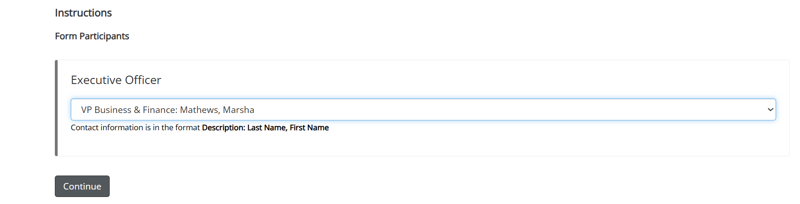
1 – Choose YOUR VP from the dropdown menu.
2 – The screen below will pop up. Please read this carefully.
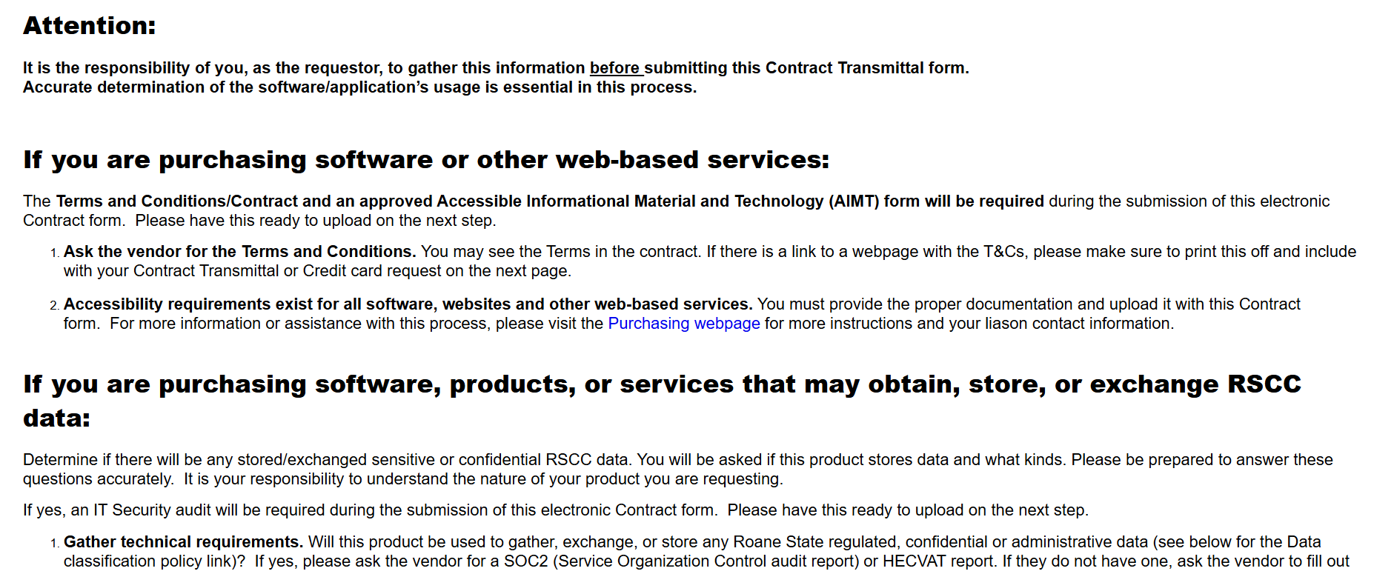

3 – When you click on next, you will see the Contract Transmittal Form.
- You will not fill in the Contract number, this will be assigned by the Contract Officer.
- You will fill in all blocks with an asterisk *.
- “Contract with” is the vendor name. The Contact name, email, phone and address are the vendor’s information which should be a person associated with the vendor.
- The Contract Purpose should be a brief summary and only one or two sentences.
- The Contract Begin Date and Contract End Date should be as close as possible to the effective date. This date cannot be changed after submission of the form.
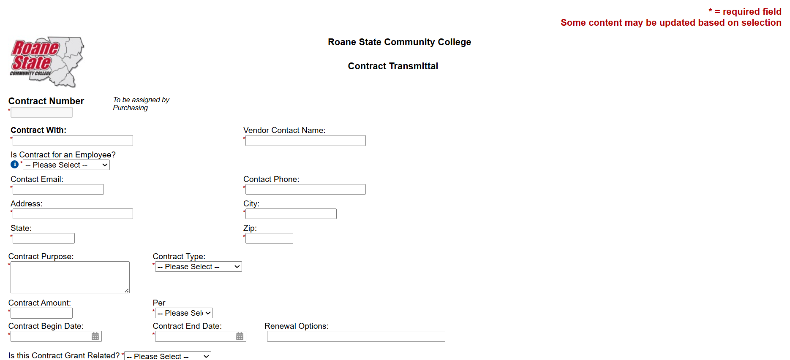

4 – If the document uploaded is Grant Related, when you click “Yes”, you will need to enter the Grant Budget Manager’s name and upload a pdf of the email stating they approve the grant document.
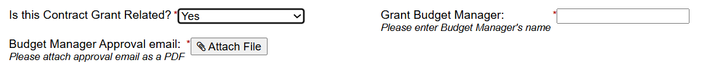

5 – You will answer yes or no to the questions below. If you answer yes, you will upload the Quote sheet in the Additional Upload Document box and attach to the requisition in Jaggaer. If it’s a Sole Source, the approved signed Sole Source form and Sole Source letter should be uploaded in the Additional Upload Document box and attached to the requisition. You will also need to reply to the next box regarding purchases over $100,000. Enter N/A if it does not apply to this transmittal.
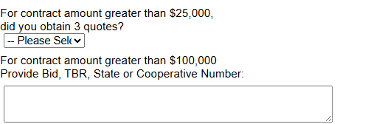
6 – The next section relates to Software. If you answer Yes, this is a contract related to Software, and Yes, Data may be stored, you will need to answer the questions below and attach the documents as required. Please keep the description to a minimum.
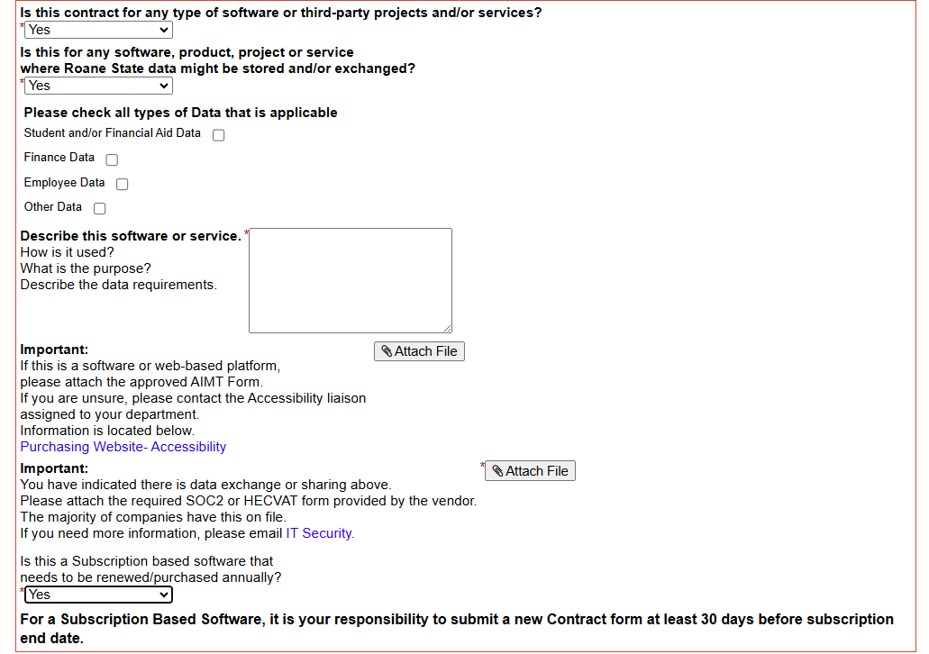

7 – Please make sure you upload any renewals at least 30 days in advance but earlier if possible.
8 – If there are specific instructions for the documents uploaded, please comment in the Additional Comments box. If this is for an amendment to a previous agreement/contract, please enter the original contract # in the Additional Comments box.
9 – Upload the contract/agreement/etc. which needs to be signed in the Upload Contract box. If there is a link at the bottom of the invoice, quote, etc. for terms and conditions, download those to a pdf to upload in the Additional Upload Document box. The two boxes are for documents related to the contract such as Terms and Conditions, Terms of Use, Master Terms, pre-approved Sole Source forms, Quote sheets, etc.
10 – Electronically sign and submit the Dynamic Form when you have completed all sections above.
11 – The remainder of the contract transmittal is for approvals based on the questions above.
- The form will be sent to your VP for approval;
- Then to the Director of Contracts for review. At this point, if needed, an amendment will be drafted and sent to the vendor for their review. This is why it is very important to enter the contact (person) name and email at the beginning of the contract transmittal.
- After the amendment has been approved by the vendor, the form will go to the approver(s) listed below based on the questions answered above.
- After the form has been through all approvals, the VP of Business and Finance will approve the form and the document will be signed by the VP’s Administrative Assistant with the President’s signature.
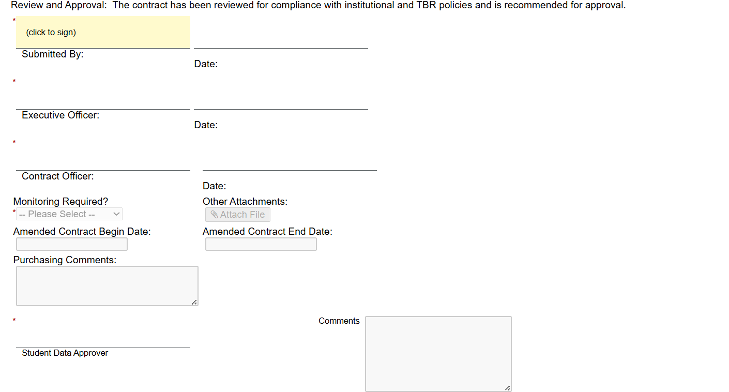
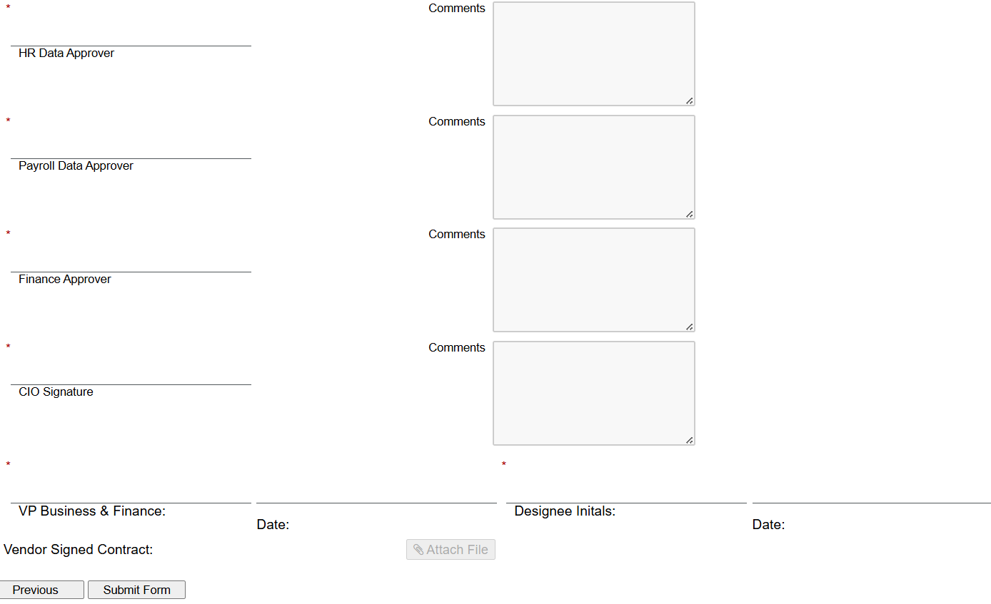

- - Once this is completed, the Director of Contracts will finalize the form which sends an email to the submitter from Dynamic Forms stating the process is complete.

- The submitter can click on the link in the email to view and save the final signed document (contract, agreement, MOU, Quote, Invoice, etc.) You will choose Forms History to view the documents to save for your records.
- It is the responsibility of the submitter to send the final signed documents to the vendor.
- If the contract/agreement/etc. is related to a purchase, the final signed documents should be attached to the requisition. Please upload the Dynamic Form on the internal side and the signed document (contract, agreement, MOU, Quote, Invoice, etc) to the external side. DO NOT attach the documents if they have not been signed and/or through the Dynamic Form transmittal process.

Please contact Dana West if you have any questions with this process at westdk2@roanestate.edu or xt.4657.

