Purchasing Department – Harriman Campus – Room D101
Purchasing, contracts, copiers and outgoing mail are handled by the Purchasing Department. Please see Purchasing’s webpage for helpful forms and instructions.
This office consists of two employees:
Dana West – Director of Purchasing, Contracts and Budgets – westdk2@roanestate.edu and xt. 4657.
Michele Oran - Buyer – oranym@roanestate.edu and xt. 4712
Purchase Orders
1 – Requisitions are entered into the Jaggaer system. There are instructions for entering requisitions on the left side of the homepage of Jaggaer.
2 – Requisitions are approved at the department level, VP of Finance - Marsha Mathews, then by the Purchasing Department – Michele Oran or Dana West.
3 – Invitations for new vendors are sent by Michele and approved by TBR.
4 – Michele can help with any questions concerning vendors and purchase orders.
Contracts and Agreements
1 – All contracts, agreements, employee work made for hire, memorandums of understanding, letters of agreement, quotes that need a signature, on-line click thru agreements, anything requiring a signature from Roane State which requires us to agree to anything will need to be sent to Dana West for review.
2 – The document mentioned above, should be sent through Dynamic Forms for the contract transmittal process. If it is a click thru agreement, this should be printed and sent for review as well.
3 – A Contract Tips sheet is at the end of this document.
Outgoing Mail
1 – Mail to be metered/stamped should be taken to the mail room at the Harriman campus. The courier will bring mail from other campuses to the Harriman campus. The mail will be placed in the outgoing mail basket by 3 pm so we can process these through the mail machine. Security then takes the mail to the post office at 4 pm daily.
2 – Please make sure the index account code is written on the outgoing mail (or on a sticky note on the envelope).
3 – If it is a stack of mail to be processed, please FOLD DOWN all flaps. This is the best way to put the envelopes through the machine.
4 – FedEx packages will also be picked up in the Purchasing Department. For pickup in the same day, you will need to bring the package to Purchasing before 2 pm. We have FedEx supplies for your use in the mailroom. Please see Michele Oran for these.

Copiers
1 – Konica Minolta copiers are in place in all offices. There is a cheat sheet for use at the end of this document. We have also placed training videos on our webpage.
2 – If there are issues with the machine operation, please call the number on the copier for maintenance. They will ask you for the copier ID. That number is on a tag on each machine.
3 – Toner and staples can be ordered by calling this number. The cost for toner is part of the contract. Staples are $37 for a box of 15,000 and will be charged to your department.
4 – We now have copier codes assigned for limited public and student use for the copiers in the Harriman and Oak Ridge campus libraries. Personnel in the libraries can help with those.
Budgets
Dana West can help with questions concerning departmental budgets. Certain journal entries can also be entered by Dana West.

CONTRACT TRANSMITTAL PROCESS
THE PRESIDENT IS THE ONLY PERSON THAT HAS THE AUTHORITY TO SIGN MOST CONTRACTS. (The VP of Business and Finance signs for the President.) Please see policy G-34-01 for the complete list of individuals who have signature authority for certain types of agreements.
A Contract Transmittal form must be completed for all contracts and agreements which will be entered through Dynamic Forms. This includes documents which have terms and conditions or make reference to terms and conditions that need to be signed for the college.
The “Contract Transmittal Form” which links to Dynamic Forms can be found on Purchasing’s webpage under Contract Information and Templates or by clicking here: https://qafederation.ngwebsolutions.com/idp/startSSO.ping?PartnerSpId=IdpRoaneStateLDAP&TargetResource=https%3a%2f%2fdynamicforms.ngwebsolutions.com%2fSubmit%2fStart%2f29498feb-7e2e-4fc5-b050-1f69bb58c963.
The Contract Transmittal Form will be signed by the Submitter then sent on to the VP for approval though Dynamic Forms. Please see Attachment A for the Dynamic Forms Contract process.
Timing
Timing for completing the process can vary widely depending on the type of contract and potential problems.
Specific actions on your part may speed up the process and make things smoother.
Make sure the facts, dates, etc. are accurate in your contract and be sure to complete any information that RSCC must provide.
Start the process as soon as possible. It takes time for reviews and approvals so plan to leave a reasonable amount of time for all of these steps to complete.
If the contract originates from the vendor, try to obtain the contract language in MS Word, if at all possible. Most contracts that originate from another party are written to protect their interests and will likely include language that we either cannot agree to or would not want to agree to. Sometimes it is easier to work out if we can take their agreement and markup our proposed additions and deletions using track changes in MS word.
The common most impermissible clauses are: indemnity, state of jurisdiction, warranty disclaimers, hold harmless clauses, attorney fees, and arbitration clauses. If you see headings or terminology such as this in your agreement, then it is probable that we will have to send an amendment for the vendor to review. The negation of the amendments can take some time so plan accordingly.
In many cases, it may be more effective to do business with a purchase order and avoid a contract with the vendor if the vendor is willing to accept our purchase order in lieu of their contract. Generally, a purchase order is not difficult to process and if we can avoid signing an agreement, protect our interests, and obtain the goods or services that you need, then this may be the best course of action.
Disclaimer: The information included in this document is intended to provide practical guidance for dealing with contract issues. Should anything in this document conflict with Federal laws, State of Tennessee Laws, TBR Polices and Guidelines, or other authoritative guidance then the applicable guidance will supersede this document.

ATTACHMENT A
SUBMITTING CONTRACTS THROUGH DYNAMIC FORMS
1 – Go to the Purchasing Webpage by clicking the link below and choose “Contract Transmittal Form” under Contract Information and Templates: https://www.roanestate.edu/?10825-Links-for-RSCC-Purchasers. This takes you to the login for Dynamic Forms to start the process.

2 – Choose the Executive Officer (your VP) on the dropdown menu
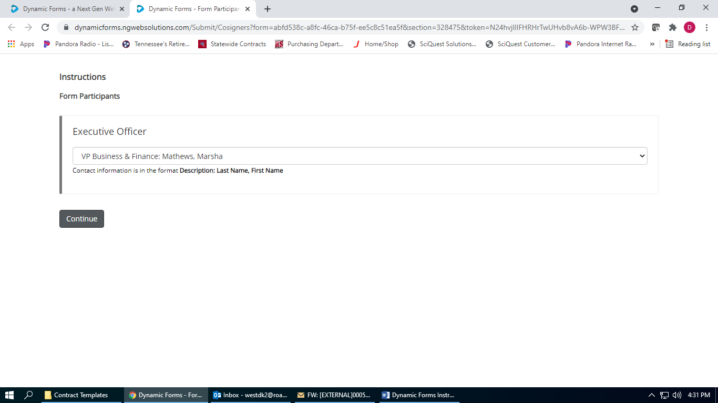

3 – You will not fill in the Contract number, this will be assigned by the Contract Officer
4 – Fill in all that cells that relate to your contract. The cells that have asterisks are required.
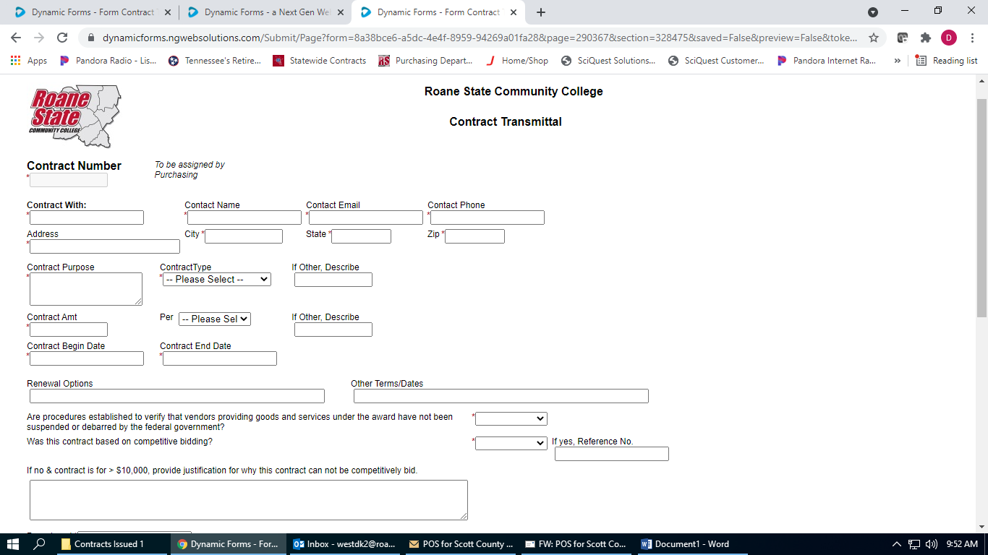

5 – Upload the contract in the box as seen below.
6 – Electronically sign and hit the submit form button.
7 –At this point, the form will be sent to your VP for signing.

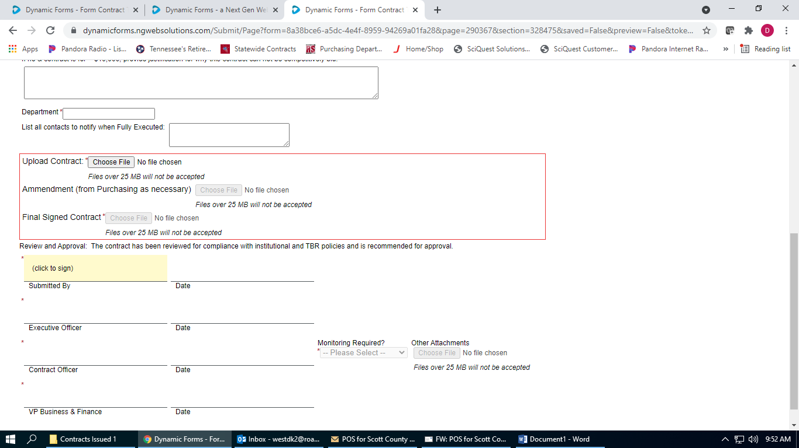

8 – The form will be sent to the Contract Officer (Dana West) to review the contract and draft any amendments that may be needed.
9 – Dana will send the amendment, if needed along with the contract to the vendor to be signed.
10 – After the contract and amendment are returned to Dana, she will upload the documents in Dynamic Forms. At this point, Dana will sign and submit the contract transmittal form.
11 - The form will then go to Marsha Mathews to review the contract and sign the contract transmittal.
10 – At this point, Beth will receive the documents to sign for Dr. Whaley.

11 – When this is complete, the submitter will receive the final documents back by Dynamic Forms through an email. You click on the link in the email which will route you to Dynamic Forms to see the completed contract as shown below. You will choose Forms History to view the documents and save as a pdf for your records.

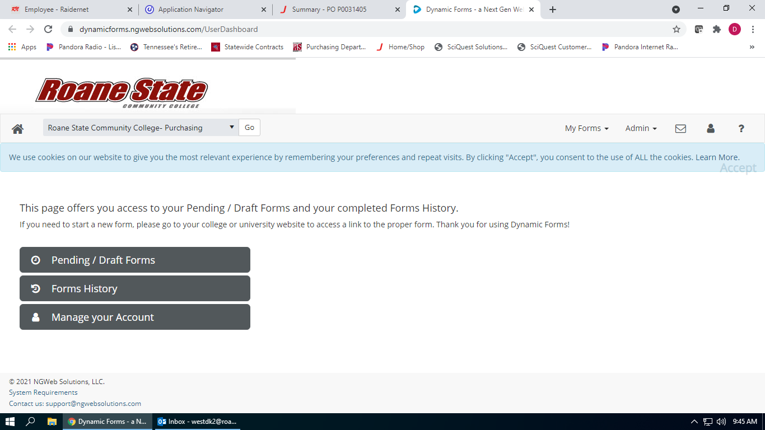

Please contact Dana West if you have any questions with this process at xt. 4657 or westdk2@roanestate.edu.

